How do these measures and benchmarks differ? In what ways do these measures and benchmarks lead to different kinds of responses? (Critical analysis rubric on next page)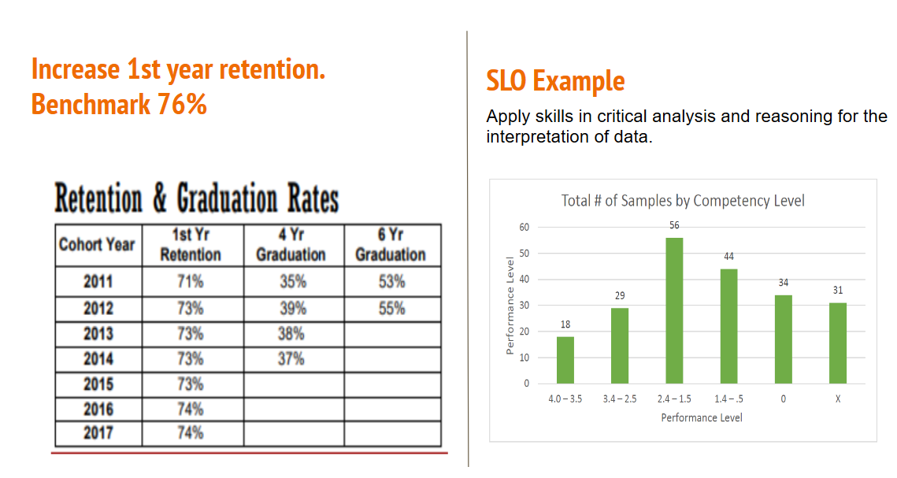

Student Learning Outcome (SLO) #3. – Apply skills in critical analysis and reasoning for the interpretation of data.

Definition: Critical thinking and reasoning are habits of mind characterized by the exploration of issues, artifacts, and events based on data before accepting or formulating an opinion or conclusion.

 | Performance Levels
 | 4 | 3 | 2 | 1
Student output and quality of work | - Problem is clearly stated and delivers all information necessary for full understanding  - Information taken from sources has been adequately interpreted and synthesized  - Viewpoints of experts are questioned thoroughly  - Systematically analyzes assumptions and carefully evaluates the relevance of contexts when presenting a position  - Specific position is imaginative; complexities and limits of position are acknowledged  - Conclusions are logical and reflect student’s informed evaluation and ability to place evidence  - Successfully completes a research project and displays an ability to independently conduct a systematic process of inquiry | - Problem is stated and clarified so that omissions do not impede process  - Information taken from sources is interpreted and evaluated for coherent analysis  - Viewpoints of experts are subject to some questioning  - Assumptions are identified when presenting a position  - Specific position takes into account the complexities of an issue; others’ points of view are acknowledged  - Conclusions are logically tied to broad range of information  - Successfully completes a project and displays an ability to conduct a systematic process of inquiry | - Problem is stated but description is a little unclear  - Information taken from sources with some interpretation, but not enough for deep analysis or synthesis  - Viewpoints from experts are taken more or less as fact; little to no questioning  - Becomes aware of some assumptions  - Specific position acknowledges different sides of an issue  - Conclusion is logically tied to a limited range of information; some implications are identified  - Needs guidance in designing a systematic process of inquiry and procedure of analysis to answer these questions | - Problem is stated without clarification or description  - Information is taken from sources as literal without any interpretation  - Viewpoints of experts are taken as fact; no questioning  - Begins to become aware of assumptions  - Specific position is stated but it is biased and simple  - Conclusion is inconsistently tied to some information; implications are not identified  - Lacks general knowledge of systematic process of inquiry and analysis
What do you like / dislike about data summary examples?
Example 1: Multiple criteria SLO Learning Environments
Assessment Instruments and Methods | Success Criteria | Summary of Findings | Response to Data & Date of Response
Measure 1 - Final evaluation instruments from both supervisors and mentors for the following items:  2a: Respect and Rapport,  2b: Culture for Learning,  2c: Classroom Procedures, 2d: Student Behavior, and 2e: Organizing Physical Space | 70% of candidates rated as proficient (top rating) on related Danielson items on final evaluation from both supervisors and mentors on each item | - According to Faculty Supervisors of student teachers, during the Spring 2018 semester,  - 74 – 85% of candidates were rated as proficient for items 2a, 2b, 2c, 2e  - only 56% of teacher candidates who completed student teaching were rated as Proficient in Element 2d: Student Behavior. However, this number jumps up to 93% when the preceding rating of Acceptable is included.  - Similar ratings by school partner mentor teachers. | Managing behavior is one aspect of the larger learning outcome and has given students trouble for some time. In response, a 1-credit online course in classroom management taken concurrently with student teaching was offered for the first time in Spring 2018. Additionally, the Office of Clinical Experience will be consulted in the Fall 2018 semester to explore the possibility of providing student teachers with targeted workshops on classroom management.
Measure 2 Survey of program completers item:  2.3: Create and manage a positive classroom environment | 85% of program completers will rate their preparation as 3=prepared, 4=very prepared). | According to a survey of Spring 2018 program completers (n=9), 89% responded that they felt either Well Prepared or Prepared in Element 2.3. This is disaggregated as 56% reporting Well Prepared and 33% reporting Prepared.

Example 2: Single measure with criterion met SLO Candidates evaluate resources to develop effective problem solving.

Assessment Instruments and Methods | Success Criteria | Summary of Findings | Response to Data & Date of Response
Measure 1 Management Plan | 80% of students will achieve exemplary or acceptable on the holistic score for the rubric. | 7 students completed the Plan. Of these 7 students, 86% scored at the exemplary or acceptable levels meeting the benchmark. Only 2 students achieved exemplary. Students demonstrated the ability to evaluate and select resources required to meet the personal, and professional needs of the stakeholders. They were able to evaluate their plans and analyze the future needs of centers. | It appears from the data that more instructional time may be needed to address needs assessment through surveys and candidates need to achieve the higher leadership levels called for to reach exemplary. We will implement plans to support and encourage more students attend or present at one state or national conference during their academic program.

Example 3: Rubric with multiple items SLO Oral presentation
Assessment Instrument & Method | Success Criteria | Summary of Findings | Response to Data
Videotaped Group Presentation assessed in MGM 399CTWI - sections 010, 020, 070 | 80% - Benchmark (16/20) 80% - Achieve It  Rubric scale was 1-4 for each of 5 items. | Mean (median) scores on rubric items:  Structure & Organization: 2.86 (3)  Eye Contact: 1.61 (1.5)  Articulation & Delivery: 2.12 (2)  Kinetics: 1.97 (2)  Slides: 2.94 (3)  Students were relatively strong on content and organization, but there was overall weakness in various dimensions of presentation delivery.

Legitimate responses to data

- Do nothing / ongoing monitor data
- Dig deeper into data / triangulate with other data (external and internal)
- Revise assessments
  - Change success criteria
  - Change holistic rubrics to more analytic rubrics
  - Change measure
- Investigate best practices
- Make changes
- Analyze effect of previous changes
- Identify changes you are already making consistent with data

Types of changes: Middle States List Standard 5
- assisting students in improving their learning;
- improving pedagogy and curriculum;
- reviewing and revising academic programs and support services;
- planning, conducting, and supporting a range of professional development activities;
- planning and budgeting for the provision of academic programs and services;
- informing appropriate constituents about the institution and its programs;
- improving key indicators of student success, such as retention, graduation, transfer, and placement rates;
- implementing other processes and procedures designed to improve educational programs and services

Top line principle: Important to show success and ways to improve (no matter how good we are)

Demonstrate Success | Continuous Improvement
Standard V “Assessment of student learning and achievement demonstrates that the institution’s students have accomplished educational goals consistent with their program of study, | Standard V.3 consideration and use of assessment results for the improvement of educational effectiveness

