Bachelor of Science in Education: Secondary Education
Certification Programs in: Biology, Chemistry, Computer Science, Computer Science & Mathematics (dual certification), Earth and Space Science, English, ESL, General Science, German, Mathematics, Physics, Physics and Mathematics (dual certification), Social Studies, and Spanish.
Minors: Secondary Education, ESL

The Secondary Education major prepares future educators with the knowledge and tools they need to be successful high school teachers. Students will learn curriculum and methods for teaching specific subjects, organization and classroom management, instructional technology and the needs of diverse learners. Students interested in teaching secondary education will find a distinct set of challenges and many rewards in this exciting field. After completing 60 credits in this program, you are eligible to be a substitute teacher. Please contact the district of interest to learn more.

Career types associated with Secondary Education
(Is this a good fit for you? Are you…)
Social - “Helper” Enterprising - “Persuader” Artistic - “Creator”

Related skills, values, and qualities
- Strong interpersonal skills and ability to communicate
ideas, facts and abstract concepts to others
- Ability to interact with people of diverse backgrounds and personalities
- Desire and ability to work with children
- Enthusiasm for teaching
- Sense of humor and friendly attitude
- Ability to organize, maintain records and meet deadlines
- Ability to use and incorporate technology into teaching
- Ability to make decisions, solve problems and remain calm in stressful situations
- Ability to adjust to close public scrutiny & criticism

Courses Secondary Education majors enjoy
- Psychology
- Public Speaking
- English
- Sociology
- Social Studies
- Science
- Math

Common interests of Secondary Edu. majors
- Working part-time or as a volunteer tutoring high school students
- Playing or coaching team sports or participating in community service organizations
- Attending lectures, workshops, or conventions related to education
- Helping to organize and plan social events
- Working part-time or as a volunteer peer/camp
counselor, tutor, 4-H leader or scout leader
- Serving as a mentor to youth
- Volunteer experience with urban youth
For more information about the major Contact the Secondary Education Department 226 Beekey, secondaryeducation@kutztown.edu,

KU Majors related to Secondary Education Elementary Education, Special Education, Library Science, Art Education, Music Education, Mathematics, English, History, Spanish, German, Biology, Physical Sciences


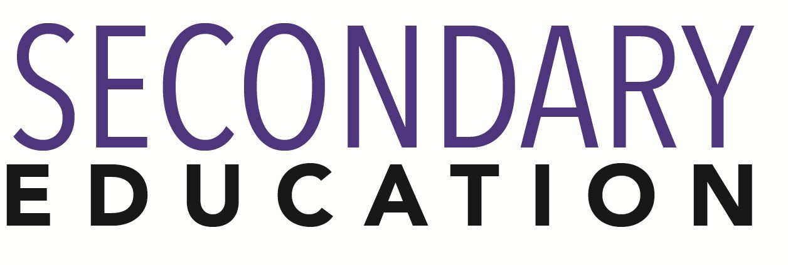

For More Information on Secondary Education Careers or to speak to a Career Counseling, contact KU Career Development Center 113 Stratton Administration Center * 610-683-4067 * careerhelp@kutztown.edu * www.kutztown.edu/careercenter

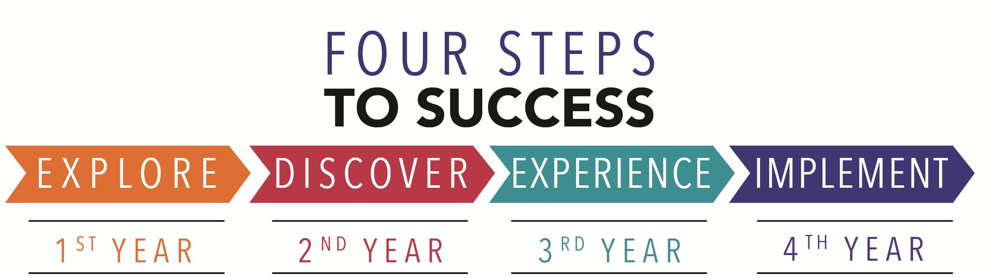

  - Enroll in the Career Exploration Certificate.
  - Attend info sessions to learn about career development and personal branding.
  - Take a career assessment to
identify and confirm interests.
  - Get involved in campus clubs and organizations.
  - Develop basic workplace skills through jobs or volunteer work.
  - Talk with professors, family, and friends about career ideas.
  - Conduct informational interviews with professionals working in fields of interest.
  - Develop a relationship with your professors and faculty advisor.
- Meet with CDC career coach.
- Attend info sessions to learn about resume writing, and externships.
- Confirm your choice of major and consider options for double major or minor.
- Research careers of interest.
- Complete a job shadowing (externship) experience.
- Seek meaningful employ-ment or volunteer work in a field related to your major.
- Explore options for under-graduate research and study abroad.
- Write a resume and have it reviewed by the CDC.
- Manage your online presence.
- Enroll in the Career Success Certificate.
- Complete an internship and/or undergraduate research.
- Attend info sessions about internships, interviewing, job search strategies, and grad school.
- Build a LinkedIn profile and continue to monitor your online presence.
- Complete a mock interview.
- Build skills through research projects, part-time employment, and volunteer work.
- Participate in Careers Cafe & networking programs.
- Attend internship & job fairs.
- Take on a leadership role in a student organization or work.
- Consider graduate school options and prepare for admissions tests.
- Attend your senior kick-off and other info sessions to prepare for job search/grad school.
- Update your resume and LinkedIn profile.
- Create cover letter drafts.
- Gain experience through internships and/or undergraduate research.
- Secure references for job/grad school applications.
- Create your “30 second”
commercial.
- Meet with CDC to develop job search strategies.
- Research employers.
- Network with professionals through events and social media.
- Join a professional organization in your discipline.
- Attend the senior etiquette
dinner.
- Participate in job fairs and on-campus interviewing.

Sample Career Titles
Secondary Education majors can be found working in a wide variety of career fields. Here are just some career titles that may be of interest. Please note that some jobs may require further education and training.

  - Adult Education Teacher
  - Adventure/Outdoor Education Teacher
  - Alumni Relations Coordinator
  - Assistant Principal
  - Athletic Coach/Director
  - Business Education Teacher
  - Child Life Specialist
  - College President
  - College Professor/Dean
  - Community/Public Svc. Administrator
  - Counselor
  - Day Care Administrator
  - Director of Guidance
  - Education and Training Administrator
  - Education Management Specialist
  - Educational Administrator
  - Education Consultant
  - Educational Materials Sales
  - Educational Researcher
  - Educational Resource Coordinator
  - Educational Therapist
  - Elementary School Teacher
  - Employee Training Instructor
  - Grant Writer
  - Guidance Counselor
  - Historic Site Administrator
  - Librarian
  - Library Consultant
  - Missionary Worker
  - Peace Corps/VISTA Volunteer
  - Personnel Director
  - Principal
  - Registrar
  - Religious Education Teacher
  - Resource Teacher

  - School Psychologist
  - School Social Worker
  - School Superintendent
  - Secondary School Teacher
  - Social Services Volunteer
  - Special Education Administrator
  - Special Education Teacher
  - Student Admissions Administrator
  - Student Affairs Administrator
  - Curriculum Specialist
  - Textbook Writer
  - Training Specialist
  - Tutor
  - Vocational Rehab Counselor
  - Vocational/Technical Teacher

To learn more about these careers, visit http://online.onetcenter.org or www.bls.gov/oco.

Common Internship Sites and Employers
Secondary Education majors often find internships and employment in the following fields/industries:

    - Business and Industry
    - Camps
    - Public and Private Schools
    - Churches
    - Colleges and Universities
    - Youth Services
    - Community Centers/Non Profits
    - Educational Publishers
    - Day Care Agencies
    - Hospitals
    - Libraries
    - State and Federal Government


Handshake is the primary online resource for preparing and connecting students and alumni
with employers. www.kutztown.edu/handshake

Useful Websites for Secondary Education Majors
Whether you are researching related career fields, applying for internships or jobs, or planning to join a professional association, these websites are for you!

Industry/Employment Information
O*NET OnLine Www.onetonline.org

Occupational Outlook Handbook. www.bls.gov/oco
PA Department of Education
www.pa.gov/agencies/education.html

NJ Department of Education www.state.nj.us/education
Education Week www.edweek.org

Job/Internship Search Boards
PA-REAP
www.pareap.net

PA-Educator.net www.pa-educator.net
Teachers-Teachers www.teachers-teachers.com

Southern Teacher’s Agency
www.southernteachers.com
Education Job Page www.nationjob.com/education

School Spring www.schoolspring.com
US-REAP
www.reap.net

Pennsylvania School Board Assoc.
www.PSBA.org

LinkedIn Jobs www.linkedin.com/jobs

Professional Associations

PA School Board Association www.psba.org
American Federation of Teachers www.aft.org
PA State Education Association
www.psea.org
National Education Association www.nea.org
Teachers of English to Speakers of Other Languages www.tesol.org
National Council of Teachers of Mathematics
www.nctm.org
National Council for the Social Studies www.socialstudies.org
National Science Teaching Association
www.nsta.org
National Council of Teachers of English
www.ncte.org
American Council on the Teaching of Foreign Languages
www.actfl.org

Building Your Resume for a Career in Secondary Education
Building a strong resume for your career field starts long before you ever start your job search. Employers want to hire graduates who not only have the necessary educational background but also have experience applying that knowledge to real life situations.

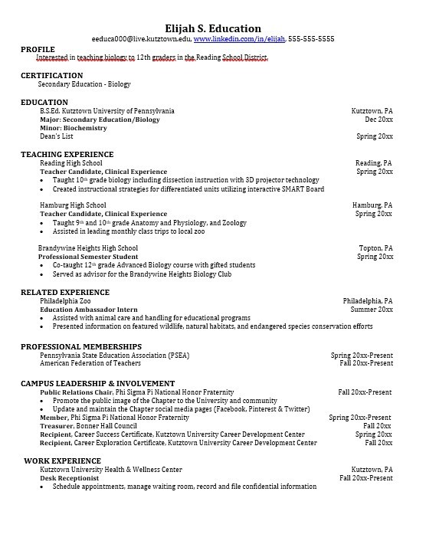
Take note of the skills and knowledge obtained through your educational background and hands-on experiences.
Highlight transfer-able skills such as presentation abilities and technological proficiencies.

Learn more about your field and develop the necessary skills for employment by gaining hands-on experience through clinical practice and related work or volunteer experience.

Develop profes-sionally through campus involvement and professional memberships.
This illustrates responsibility, leadership abilities and time management skills.

For More Information on Secondary Education Careers or to speak to a Career Counseling, contact KU Career Development Center 113 Stratton Administration Center * 610-683-4067 * careerhelp@kutztown.edu * www.kutztown.edu/careercenter

