

Bachelor of Arts: Sociology Minor: Sociology

Sociology is the study of society and social behavior and focuses on the interaction between population groups and institutions and their influences on each other. Students will develop a deeper understanding of diversity through courses in deviant behavior, environmental sociology, and social inequality. Additionally, a variety of courses in such areas as family, gender and LGBTQ studies, as well as immigration are offered.

A degree in Sociology is ideal for students who wish to pursue graduate studies and/or careers in business, government, non-profit organizations, behavioral health, health care management, social service and criminal justice agencies, and community development and action groups. Employers recommend one or more internships to be successful and competitive when entering this field.

Career types associated with Sociology (Is this a good fit for you? Are you…) Investigative - “Thinker”
Enterprising - “Leader”
Realistic - “Doer”

Related skills, values, and qualities
- Strong interpersonal communication skills
- Proficiency in reading comprehension, writing and speaking
- Ability to conduct and explain sociological research
- Ability to interact with people of diverse backgrounds and situations
- Ability to maintain composure in stressful situations
- Ability to adapt to new environments and improvise when needed
- Ability to evaluate problems and make appropriate decisions

Courses Sociology majors typically enjoy
- Anthropology
- Economics
- Environmental Studies
- Health
- History
- International Studies
- Psychology
- Political Science
- Public Administration
- Social Studies

Common interests of Sociology majors
- Social activism
- Participating in charitable outreach efforts and raising funds for social concerns
- Joining school clubs and organizations
- Working part-time or volunteering in a day care
center or community service agency
- Planning events
- Reading social-issue related publications and attending lectures and conferences related to

For more information about the major Contact Department of Society, History & Culture 2 Old Main, 610-683-4242
or visit www.kutztown.edu/Sociology

KU Majors related to Sociology Anthropology, Political Science, Criminal Justice, Education, Geography, Sport Management, Psychology, Social Work

For More Information on Sociology careers or to speak to a Career Counselor, contact KU Career Development Center 113 Stratton Administration Center * 610-683-4067 * careerhelp@kutztown.edu * www.kutztown.edu/careercenter



- Enroll in the Career Exploration Certificate.
- Attend info sessions to learn about career development and personal branding.
- Take a career assessment to
identify and confirm interests.
- Get involved in campus clubs and organizations.
- Develop basic workplace skills through jobs or volunteer work.
- Talk with professors, family, and friends about career ideas.
- Conduct informational interviews with professionals working in fields of interest.
- Develop a relationship with your professors and faculty advisor.
- Meet with CDC career coach.
- Attend info sessions to learn about resume writing, and externships.
- Confirm your choice of major and consider options for double major or minor.
- Research careers of interest.
- Complete a job shadowing (externship) experience.
- Seek meaningful employ-ment or volunteer work in a field related to your major.
- Explore options for under-graduate research and study abroad.
- Write a resume and have it reviewed by the CDC.
- Manage your online presence.
- Enroll in the Career Success Certificate.
- Complete an internship and/or undergraduate research.
- Attend info sessions about internships, interviewing, job search strategies, and grad school.
- Build a LinkedIn profile and continue to monitor your online presence.
- Complete a mock interview.
- Build skills through research projects, part-time employment, and volunteer work.
- Participate in Careers Cafe & networking programs.
- Attend internship & job fairs.
- Take on a leadership role in a student organization or work.
- Consider graduate school options and prepare for admissions tests.
- Attend your senior kick-off and other info sessions to prepare for job search/grad school.
- Update your resume and LinkedIn profile.
- Create cover letter drafts.
- Gain experience through internships and/or undergraduate research.
- Secure references for job/grad school applications.
- Create your “30 second”
commercial.
- Meet with CDC to develop job search strategies.
- Research employers.
- Network with professionals through events and social media.
- Join a professional organization in your discipline.
- Attend the senior etiquette
dinner or luncheon.
- Participate in job fairs and on-campus interviewing.

Sample Career Titles
Sociology majors can be found working in a wide variety of career fields. Here are just some career titles that may be of interest. Please note that some jobs may require further education and training.
To learn more about these careers, visit http://online.onetcenter.org or www.bls.gov/oco.

  - Admissions Counselor
  - Adoption Agent
  - Advertising Manager
  - Aging Specialist
  - Child Welfare Officer
  - Community & Social Service Worker
  - Community Relations Director
  - Consultant
  - Consumer Survey Advisor
  - Convention Organizer
  - Correctional Caseworker/Officer
  - Counselor: Alcohol/Drug
  - Counselor: Career
  - Counselor: Crisis Intervention
  - Counselor: Occupational
  - Counselor: School/Guidance
  - Counselor: Vocational/Voc. Rehab
  - Criminologist
  - Demographic Analyst
  - Employee Assistance Director
  - Employee/Labor Relations Mgr.
  - EEO/AA Specialist
  - Family Preservation Case Worker
  - Family Services Specialist
  - Financial Aid Director
  - Foster Care Worker
  - Fundraiser/Development Officer
  - Gerontologist
  - Group Therapist
  - Hospice Coordinator
  - Human Resources Administrator
  - Independent Living Trainer
  - International Student Advisor
  - Job Analyst & Developer
  - Labor Relations Specialist
  - Lawyer
  - Market Research Analyst
  - Mental Health Professional
  - Minority & Race Relations Specialist
  - Motivational Speaker/Researcher
  - News Correspondent/Reporter
  - Outplacement Specialist
  - Peace Corps/VISTA Worker
  - Paralegal
  - Parole/Probation Officer
  - Political Systems Researcher
  - Public Health Educator/Statistician
  - Public Opinion Surveyor
  - Public Relations Specialist
  - Recreation Director
  - Recreation Therapist
  - Regulatory Administrator
  - Social Service Administrator
  - Social Movements Organizer
  - Social Scientist
  - Social Welfare Examiner
  - Sociologist
  - Statistician Analyst
  - Teacher/Professor/Educator
  - Therapeutic Staff Support Person
  - Wage/Benefits Analyst
  - Youth Corrections Officer

Common Internship Sites and Employers
Sociology majors often find internships and employment in the following fields/industries.

- Business & Industry
- Community Agencies
- Correctional Facilities
- Educational Institutions
- Mental Health Agencies
- Museums
- Non-Profit Organizations
- Private Practice
- Rehabilitation Agencies & Hospitals
- Research Foundations
- State/Federal Government Agencies



Handshake is the primary online resource
for preparing and connecting students and alumni with employers.
www.kutztown.edu/handshake

Useful Websites for Sociology Majors
Whether you are researching related career fields, applying for internships or jobs, or planning to join a professional association, these websites are for you!

Industry Information & Job/Internship Search Sites
Careers in Federal Government www.usajobs.gov

Idealist: Non-Profit Opportunities www.idealist.org
LaSalle Non-Profit Center
www.lasallenonprofitcenter.org

Non Profit Job Search http://nonprofit-jobs.org
The New Social Worker Online www.socialworker.com
Saludos Hispanos Career Center www.saludos.com/cguide/cswguide.html

Social Service Jobs www.socialservice.com
LinkedIn Job Search www.linkedin.com/jobs

Professional Associations

American Association for Marriage
& Family Therapy
www.aamft.org

American Counseling Association www.counseling.org
American Sociological Association www.asanet.org
Association for Applied & Clinical Sociology
www.aacsnet.org

Association for the Sociology of Religion www.sociologyofreligion.com
Association of Black Sociologists www.associationofblacksociologists.org

Eastern Sociological Society
www.essnet.org

International Sociological Association www.isa-sociology.org
Society for Human Resource Manage-ment www.shrm.org

Society for the Study of Social Problems www.sssp1.org

Related Area Employers

Berks County Pretrial Services Bethany’s Children’s Home Creative Health Services
Kaleidoscope Family Solutions, Inc. KidsPeace
Lehigh Valley Center for
Independent Living Lehigh Valley Health Network St. Luke’s Health Network

Building Your Resume for a Career in Sociology

Develop professionally through campus involvement and professional memberships.
This illustrates responsibility, leadership abilities and time management skills.
Utilize summer breaks to acquire valuable experience via volunteer or employment opportunities related to your major.

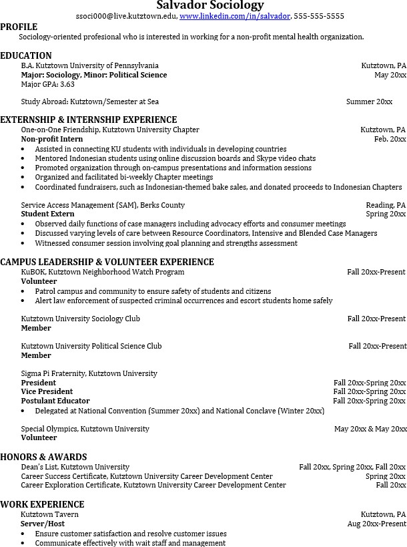
Building a strong resume for your career field starts long before you ever start your job search. Employers want to hire graduates who not only have the necessary educational background but also have experience applying that knowledge.
Learn more about your field and develop the necessary skills for employment by gaining hands-on experience through internships.

For More Information on Sociology careers or to speak to a Career Counselor, contact KU Career Development Center 113 Stratton Administration Center * 610-683-4067 * careerhelp@kutztown.edu * www.kutztown.edu/careercenter

