

Bachelor of Arts: Anthropology Minor: Anthropology

Anthropology is the study of people, their origins, physical nature, and social behavior. Through the Bachelor of Arts program at KU, students gain a broad and versatile understanding of human behavior and biology from the past to the present. This program provides rich diversity and academic potential in four major areas: linguistic anthropology, cultural anthropology, physical/biological anthropology, and archaeology. A summer field school experience where students learn the latest excavation and mapping techniques is also offered. We also have a museum on campus with opportunities for internships and community interaction.
A degree in Anthropology is ideal for students who wish to pursue graduate studies and/or careers in government, business, social services, the news media, museums, community activism or education.

Career types associated with Anthropology
(Is this a good fit for you? Are you a…)
- Investigative - “Thinker”
- Realistic - “Doer”
- Enterprising - “Leader”

Related skills, values, and qualities
- Proficiency in reading comprehension, writing and public speaking
- Ability to conduct and explain scientific research
- Proficiency with computers and social media
- Ability to interpret and evaluate cultural events, information, and ideas
- Interpersonal communication skills
- Interest in languages and other cultures
- Strong listening, clarifying, questioning, and responding skills
- Ability to adapt to new environments and improvise when needed

Courses Anthropology majors typically enjoy
- Anatomy/Physiology
- Art History
- Foreign Languages
- Geography
- History
- Philosophy
- Psychology
- Sociology

Common interests of Anthropology majors
- Visiting libraries, museums, cultural festivals, community events
- Participating in cultural preservation efforts or reenactments, community organizations, societies or action groups
- Exploring and learning about other people and cultures Working or volunteering in community events or centers
- Participating in archaeological field experiences
- Examining material culture, relics and artifacts
- Working or volunteering in a museum, community center, cultural center or site
- Reading publications related to history, culture, cultural change, evolution
- Learning about different peoples and cultures both in US and other countries

For more information about the major Contact Department of Society, History & Culture 2 Old Main, 610-683-4242 or visit www.kutztown.edu/Anthropology
KU Majors related to Anthropology Geography, History, Psychology, Sociology, Philosophy

For More Information on Anthropology careers or to speak to a Career Counselor, contact KU Career Development Center 113 Stratton Administration Center * 610-683-4067 * careerhelp@kutztown.edu * www.kutztown.edu/careercenter



- Enroll in the Career Exploration Certificate.
- Attend info sessions to learn about career development and personal branding.
- Take a career assessment to
identify and confirm interests.
- Get involved in campus clubs and organizations.
- Develop basic workplace skills through jobs or volunteer work.
- Talk with professors, family, and friends about career ideas.
- Conduct informational interviews with professionals working in fields of interest.
- Develop a relationship with your professors and faculty advisor.
- Meet with CDC career coach.
- Attend info sessions to learn about resume writing, and externships.
- Confirm your choice of major and consider options for double major or minor.
- Research careers of interest.
- Complete a job shadowing (externship) experience.
- Seek meaningful employ-ment or volunteer work in a field related to your major.
- Explore options for under-graduate research and study abroad.
- Write a resume and have it reviewed by the CDC.
- Manage your online presence.

- Enroll in the Career Success Certificate.
- Complete an internship and/or undergraduate research.
- Attend info sessions about internships, interviewing, job search strategies, and grad school.
- Build a LinkedIn profile and continue to monitor your online presence.
- Complete a mock interview.
- Build skills through research projects, part-time employment, and volunteer work.
- Participate in employer panels, site visits, & networking events
- Attend internship & job fairs.
- Take on a leadership role in a student organization or work.
- Consider graduate school options and prepare for admissions tests.
- Attend your Senior Kick-off session and other info sessions to prepare for job search/grad school.
- Update your resume and LinkedIn profile.
- Create cover letter drafts.
- Gain experience through internships and/or undergraduate research.
- Secure references for job/grad school applications.
- Create your “30 second”
commercial/elevator pitch.
- Meet with CDC to develop job search strategies.
- Research employers.
- Network with professionals through events and social media.
- Join a professional organization
in your discipline.
- Attend the senior etiquette luncheon or dinner.
- Participate in job fairs and on-campus interviewing.

Sample Career Titles
Anthropology majors can be found working in a wide variety of career fields. Here are just some career titles that may be of interest. Please note that some jobs may require further education and training.

  - Academic Advisor/Counselor
  - Advertiser
  - Archaeologist
  - Archivist
  - Assessment Researcher
  - Behavioral Science Advisor
  - Bilingual/Bicultural Program
  - Biographer
  - Caseworker
  - College Professor
  - Community Development Officer
  - Community Planner Consultant
  - Corporate Communications
  - Cultural Artifact Specialist
  - Cultural Resource Manager
  - Employee Relations Specialist
  - Employment Recruiter
  - Environmental Impact Consultant
  - Ethnologist
  - Field Archaeologist
  - Foreign Affairs Officer
  - Forensic Anthropologist
  - Foundation Program Manager
  - Genealogist
  - Genetic Counselor
  - Government/Public Service
  - Health Scientist
  - Human Resources Manager
  - Immigration Inspector
  - Industrial Psychologist
  - International Agency Rep.
  - Interpreter
  - Librarian
  - Linguist
  - Management Consultant
  - Medical Anthropologist
  - Model Designer
  - Multicultural Education
  - Museum Curator/Technician
  - Museum Education Director
  - National/State Parks Officer
  - Paleontologist
    - Park Service Supervisor/Director
    - Peace Corps/VISTA Worker
    - Personnel Management Specialist
    - Public Health Educator
    - Research Anthropologist
    - Researcher/Educator
    - Rural Development Officer
    - Social Science Analyst
    - Social Service Agency Planner Specialist
    - Staff Training Specialist
    - State/Federal Government Policy Analyst
    - Teacher, English as a Second Language
    - Technical Writer
    - Tour Guide
    - Travel Agent/Guide
    - Travel Consultant
    - Vocational Teacher
    - Zookeeper/Animal Curator

Common Internship Sites and Employers
Anthropology majors often find internships and employment in the following fields/industries.

- Business & Industry
- Colleges/Universities
- Hospitals
- Humanitarian Agencies
- International Organizations
- Museums
- Non-Profit Organizations
- Research Laboratories
- US Park Service
- Zoological Gardens



Handshake is the primary online resource
for preparing and connecting students and alumni with employers.
www.kutztown.edu/handshake

Useful Websites for Anthropology Majors
Whether you are researching related career fields, applying for internships or jobs, or planning to join a professional association, these websites are for you!

Industry/Employment Information

Archeology Magazine www.archaeology.org

Environmental Careers World Job Bank www.environmentaljobs.com

U. Penn Museum of Archeology &
Anthropology www.penn.museum

Science Careers www.sciencecareers.org
ScienceJobs www.scientist.com
Shovelbums www.shovelbums.org

Smithsonian http://naturalhisotry.si.edu/research/ anthropology

LinkedIn Jobs www.linkedin.com/jobs

Professional Associations

American Academy of Forensic Science www.aafs.org
American Anthropological Association https://americananthro.com

American Association of Biological Anthropologists www.bioanthro.org

American Association for the Advancement of Science www.aaas.org

Archaeological Institute of America www.archaeological.org

Counsel for the Advancement of Science Writing
www.casw.org

The National Academies www.nationalacademies.org
National Association for the Practice of Anthropology http://practicinganthropology.org

Society for American Archaeology www.saa.org

Society for Applied Anthropology www.sfaa.net

Related Area Employers

Alice Paul Institute Allentown Art Museum
Brandywine River Museum of Art Heritage Conservancy
Historic Bethlehem Museums and Sites
Kaleidoscope Family Solutions
KidsPeace
Kutztown Area Historical Society Kutztown Community Partnerships Pennsylvania German Cultural
Heritage Center United Way of Berks County United Way of Greater Lehigh
Valley

Building Your Resume for a Career in Anthropology

Develop professionally through campus involvement and professional memberships.
This illustrates responsibility, leadership abilities and time management skills.
Utilize summer breaks to acquire valuable experience via volunteer or employment opportunities related to your major.

Building a strong resume for your career field starts long before you ever start your job search. Employers want to hire graduates who not only have the necessary educational background
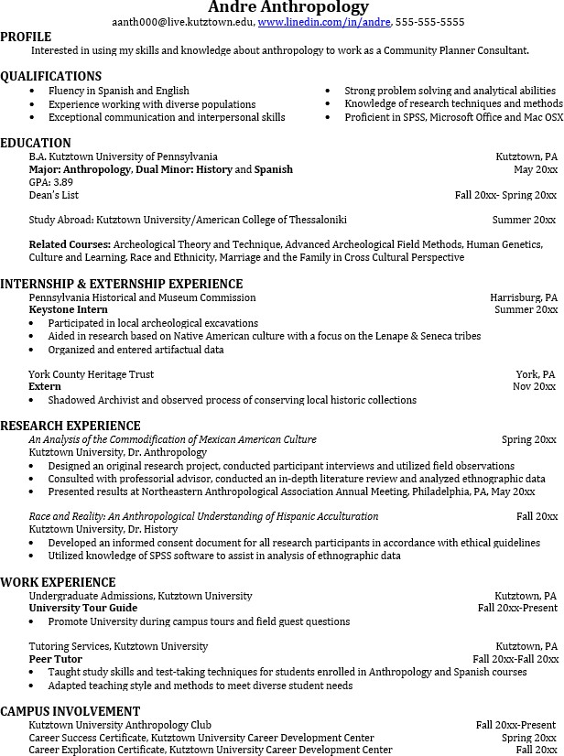
but also have experience applying that knowledge.

Learn more about your field and develop the necessary skills for employment by gaining hands-on experience through internships & related experiences.

For More Information on Anthropology careers or to speak to a Career Counselor, contact KU Career Development Center 113 Stratton Administration Center * 610-683-4067 * careerhelp@kutztown.edu * www.kutztown.edu/careercenter

