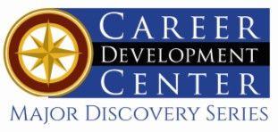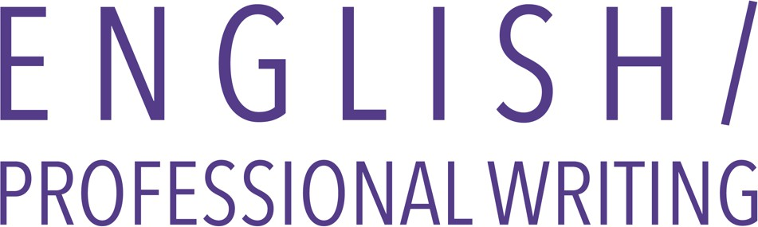
Bachelor of Arts: English
Bachelor of Arts: Professional Writing Bachelor of Arts: English/Paralegal Bachelor of Science: Public Relations
Minors: Literature, and Professional Writing, Digital Communications & New Media, Public Relations Certificate: Technical Writing
English is an area of language arts that emphasizes the written works but also includes the study of literature, speech, and writing in all its forms. English majors develop their ability to think logically, read critically, and communicate effectively while heightening their aesthetic awareness and their understanding of fundamental human issues as they appear in works from various historical and cultural settings. An English major is ideal for students who wish to pursue entrance into graduate programs or law school and/or careers in a variety of settings including publishing, advertising, writing, editing, business, public relations and education.
Professional writers work in every industry, government agency, and influential institution. They are behind the content and branding of all entertainment media. They write news stories, technical documents, podcasts, user manuals, games, novels, poetry, social media, screenplays, grants, reviews, analyses, and so much more.
Employers recommend one or more internships to be successful and competitive when entering this field.

Career types associated with English
(Is this a good fit for you? Are you a…)
- Artistic - “Creator”
- Social - “Helper”
- Enterprising - “Leader”

Skills associated with the English & Professional
Writing majors
- Proficiency in written and oral communication skills
- Flexible, precise editorial skills for various communications environments
- Ability to write in various styles for distinct, diverse audiences
- Ability to conduct research and explain results
- Ability to read analytically and interpret critically
- Ability to sustain concentration for prolonged periods
- Ability to cultivate imaginative, empathetic responses to ethically complex situations

Courses English & Professional Writing majors typically enjoy
- Anthropology
- Drama
- History
- Humanities
- Sociology
- Public Speaking
- Writing

Common interests of majors
- Attending movies, plays, lectures, or readings
- Participating in theatre productions
- Writing short stories, poetry, or news articles
- Conversing with others
- Participating in a book club, student newspaper,
or yearbook club
- Reading essays, articles, novels, short stories, plays, poetry, and professional journals
- Visiting libraries
- Working part-time or as a volunteer for a library, high school/college radio or TV station, or nonprofit organization

For more information about the majors
Contact the English Department, 132 Lytle, 610-683-4353, or visit www.kutztown.edu/English

Related KU majors
Communication Studies, History, Philosophy, Secondary Education, Social Media Theory & Strategy

Artistic students may also be interested in: Art, Art Education, Communication Studies,
Communication Design, Crafts, Elementary Education, German Studies, International Studies*, Library Science, Music, Music Education, Public Relations, Spanish
*minor only

For More Information on English careers or to speak to a Career Counselor, contact KU Career Development Center 113 Stratton Administration Center * 610-683-4067 * careerhelp@kutztown.edu * www.kutztown.edu/careercenter

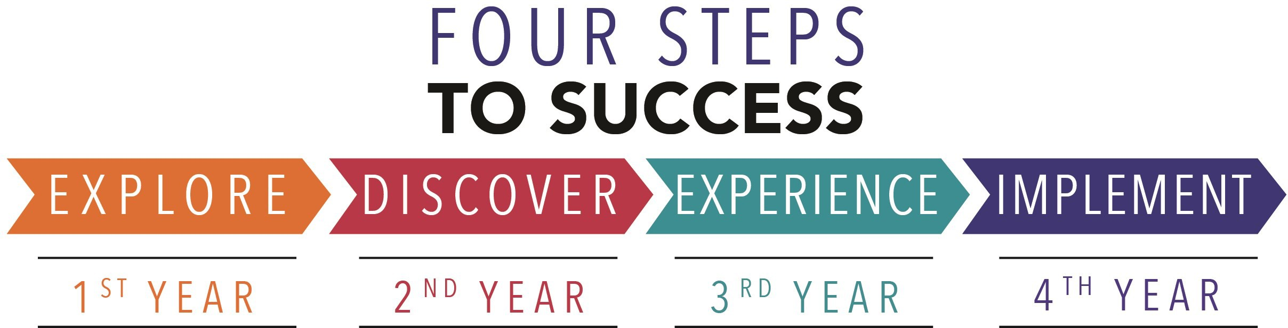

- Enroll in the Career Exploration Certificate.
- Attend info sessions to learn about career development and personal branding.
- Take a career assessment to
identify and confirm interests.
- Get involved in campus clubs and organizations.
- Develop basic workplace skills through jobs or volunteer work.
- Talk with professors, family, and friends about career ideas.
- Conduct informational interviews with professionals working in fields of interest.
- Develop a relationship with your professors and faculty advisor.
- Meet with CDC career coach.
- Attend info sessions to learn about resume writing, and externships.
- Confirm your choice of major and consider options for double major or minor.
- Research careers of interest.
- Complete a job shadowing (externship) experience.
- Seek meaningful employ-ment or volunteer work in a field related to your major.
- Explore options for under-graduate research and study abroad.
- Write a resume and have it reviewed by the CDC.
- Manage your online presence.

- Enroll in the Career Success Certificate.
- Complete an internship and/or undergraduate research.
- Attend info sessions about internships, interviewing, job search strategies, and grad school.
- Build a LinkedIn profile and continue to monitor your online presence.
- Complete a mock interview.
- Build skills through research projects, part-time employment, and volunteer work.
- Participate in employment panels, site visits & networking events.
- Attend internship & job fairs.
- Take on a leadership role in a student organization or work.
- Consider graduate school
options and prepare for
- Attend your Senior Kick-off session and other info sessions to prepare for job search/grad school.
- Update your resume and LinkedIn profile.
- Create cover letter drafts.
- Gain experience through internships and/or undergraduate research.
- Secure references for job/grad school applications.
- Create your “30 second”
commercial/elevator pitch.
- Meet with CDC to develop job search strategies.
- Research employers.
- Network with professionals through events and social media.
- Join a professional organization
in your discipline.
- Attend the senior etiquette luncheon or dinner.
- Participate in job fairs and on-campus interviewing.

Sample Career Titles
English and Professional Writing majors can be found working in a wide variety of career fields. Here are just some career titles that may be of interest. Please note that some jobs may require further education and training.
To learn more about these careers, visit http://online.onetcenter.org or www.bls.gov/oco.

  - Advertising Copywriter/Executive
  - Announcer (Radio/TV)
  - Archivist
  - Author
  - Bibliographer
  - Biographer
  - Book Critic
  - Bookstore Manager
  - Columnist/Commentator
  - Comedy Writer
  - Communications Manager
  - Congressional Aide
  - Copywriter
  - Critic, Art/Book
  - Crossword Puzzle Developer
  - Desktop Publisher
  - Documentation Specialist
  - Editor, Film/Video/Magazine
  - Editor, News
  - Educational Program Specialist
  - Entertainment Agent
  - ESL Teacher
  - Freelance Writer/Consultant
  - Information Abstractor/Indexer
  - Labor Relations Specialist
  - Lawyer
  - Librarian
  - Linguist
  - Literary Agent
  - Lobbyist
  - Magazine Writer
  - Manuscript Reader
  - Market Research Analyst
  - Marketing Specialist
  - Mass Media Script Reader
  - Media Planner
  - Narrator
  - Paralegal
  - Playwright/Poet
  - Product Manager
  - Proofreader
  - Public Relations Specialist
  - Public Speaker
  - Publicity Assistant
  - Publisher
  - Reading Consultant/Specialist
  - Reporter
  - Research Assistant Analyst
  - Researcher/Pollster
  - Reviewer
  - Sales Representative
  - Teacher
  - Technical Writer/Consultant
  - Training Specialist
  - Translator
  - Underwriter
  - Video Scriptwriter/Producer

Common Internship Sites and Employers
English and Professional Writing majors often find internships and employment in the following fields/industries.

    - News and Media
    - Book Publishers
    - Colleges/Universities
    - Consulting Firms
    - Public Relations Firms
    - Business and Industry
    - Telecommunications Organizations
    - Non-profit Organizations
    - Radio Stations
    - Libraries



Handshake is the primary online resource
for preparing and connecting students and alumni with employers.
www.kutztown.edu/handshake

Useful Websites for English & Professional Writing Majors
Whether you are researching related career fields, applying for internships or jobs, or planning to join a professional association, these websites are for you!

Industry/Employment Information

Book Jobs http://bookjobs.com

Internship Programs www.internshipprograms.com
Journalism Jobs
www.journalismjobs.com

Pennsylvania Newspaper Association http://panewsmedia.org
Poets & Writers www.pw.org

PRSA Job Center www.prsa.org/jobcenter
Public Relations www.nationjob.com/publicrelations
The Write Jobs
www.writerswrite.com/jobs

Work in Public Relations www.marketingjobs.com
Writer’s Resource Center
www.poewar.com

LinkedIn Jobs www.linkedin.com/jobs

Professional Associations

American Society of Journalists & Authors www.asja.org

Association of Writers & Writing Programs www.awpwriter.org
Association for Education in Journalism & Mass Communications www.aejmc.org
Modern Language Association www.mla.org

National Council for Teachers of English www.ncte.org
Public Relations Society of America www.prsa.org

Society for Technical Communication www.stc.org
The Association of Magazine Media http://www.magazine.org

Related Area Employers
Alliance for Sustainable Communities Altitude Marketing
Animal Rescue League of Berks County APSCUF
ArtsQuest
Berks County Living Berks-Mont News Clark Associates, Inc.
Da Vinci Science Center DaBrian Marketing Group Hawk Mountain Sanctuary Hershey Entertainment & Resorts
Great Valley Publishing Company Kutztown University: University Relations Lehigh Valley Press
Lehigh Valley Style Merion West
PBS 39
Picture this Post Reminder Media Rodale Institute Strunk Media Group The Morning Call
The Washington Center
Unisys
United Way WPMT FOX43

Building Your Resume for a Career in English & Professional Writing

Develop professionally through campus involvement and professional memberships.
This illustrates responsibility, leadership abilities and time management skills.
Utilize summer breaks to acquire valuable experience via volunteer or employment opportunities related to your major.
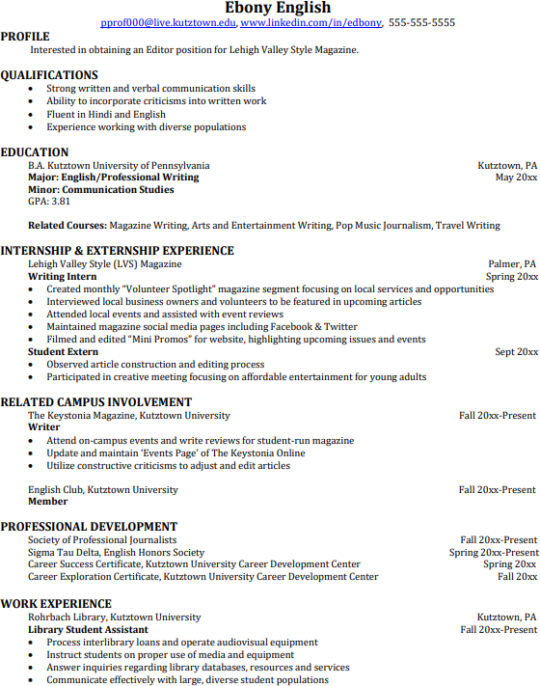
Building a strong resume for your career field starts long before you ever start your job search. Employers want to hire graduates who not only have the necessary educational background but also have experience applying that knowledge.

Learn more about your field and develop the necessary skills for employment by gaining hands-on experience through internships & related experiences.

For More Information on English careers or to speak to a Career Counselor, contact KU Career Development Center 113 Stratton Administration Center * 610-683-4067 * careerhelp@kutztown.edu * www.kutztown.edu/careercenter

