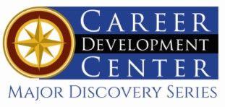

Bachelor of Arts: History
Bachelor of Arts: History with Paralegal Studies Minor: History, Public History, Archives and Museums

History is the study of past human experience. Working with written, oral, visual information and artifacts, history majors examine the causes, context and chronologies of major social, political, cultural, and economic events to understand how human experiences have changed over time.

The Bachelor of Arts degree at KU is designed to prepare students for entrance into graduate programs or careers in law, government, museum work, and historical preservation. Business and industry commonly employ history graduates because of their advanced writing, analytic, and research skills. Employers recommend one or more internships to be successful and competitive when entering the field.

Career types associated with History
(Is this a good fit for you? Are you a…)
- Enterprising - “Leader”
- Social - “Helper”
- Realistic - “Doer”

Related skills, values, and qualities
- Strong oral and written communication skills
- Proficiency in reading comprehension, writing and speaking
- Ability to identify and evaluate records of past events, ideas, and facts
- Ability to conduct and explain historical research
- Ability to collect and organize important historical data
- Ability to make critical observations, solve problems, and make appropriate decisions
- Proficiency for accuracy and detail

Courses History majors typically enjoy
- Anthropology
- Civics/Government
- History
- Modern/Foreign Languages
- Social Studies
- Sociology
- Geography

Common interests of History majors
  - Visiting libraries and museums
  - Participating in historical preservation efforts or reenactments
  - Traveling
  - Participating in activities that involve research
  - Collecting relics and artifacts
  - Working part-time or volunteering in a museum, antique shop or other historical site
  - Reading history-related publications
  - Viewing historical dramas or documentaries

For more information about the major
Contact the Department of Society, History & Culture 2 Old Main or visit www.kutztown.edu/History

KU Majors related to History
Anthropology, Political Science, English-Professional Writing, Geography

For More Information on History careers or to speak to a Career Counselor, contact KU Career Development Center 113 Stratton Administration Center * 610-683-4067 * careerhelp@kutztown.edu * www.kutztown.edu/careercenter



- Enroll in the Career Exploration Certificate.
- Attend info sessions to learn about career development and personal branding.
- Take a career assessment to
identify and confirm interests.
- Get involved in campus clubs and organizations.
- Develop basic workplace skills through jobs or volunteer work.
- Talk with professors, family, and friends about career ideas.
- Conduct informational interviews with professionals working in fields of interest.
- Develop a relationship with your professors and faculty advisor.
- Meet with CDC career coach.
- Attend info sessions to learn about resume writing, and externships.
- Confirm your choice of major and consider options for double major or minor.
- Research careers of interest.
- Complete a job shadowing (externship) experience.
- Seek meaningful employ-ment or volunteer work in a field related to your major.
- Explore options for under-graduate research and study abroad.
- Write a resume and have it reviewed by the CDC.
- Manage your online presence.
- Enroll in the Career Success Certificate.
- Complete an internship and/or undergraduate research.
- Attend info sessions about internships, interviewing, job search strategies, and grad school.
- Build a LinkedIn profile and continue to monitor your online presence.
- Complete a mock interview.
- Build skills through research projects, part-time employment, and volunteer work.
- Participate in employment panels, site visits & networking events.
- Attend internship & job fairs.
- Take on a leadership role in a student organization or work.
- Consider graduate school
options and prepare for
- Attend your Senior Kick-off and other info sessions to prepare for job search/grad school.
- Update your resume and LinkedIn profile.
- Create cover letter drafts.
- Gain experience through internships and/or undergraduate research.
- Secure references for job/grad school applications.
- Create your “30 second”
commercial/elevator pitch.
- Meet with CDC to develop job search strategies.
- Research employers.
- Network with professionals through events and social media.
- Join a professional organization in your discipline.
- Attend the senior etiquette
luncheon or dinner.
- Participate in job fairs and on-campus interviewing.

Sample Career Titles
History majors can be found working in a wide variety of career fields. Here are just some career titles that may be of interest. Please note that some jobs may require further education and training.
To learn more about these careers, visit http://online.onetcenter.org or www.bls.gov/oco.

  - Anthropologist
  - Archeologist
  - Archivist
  - Attorney
  - Biographer
  - Blogger
  - College Admissions
  - Congressional Aide
  - Consumer Advocate
  - Demographer
  - Economist
  - Editor
  - FBI/CIA Agent
  - Foreign News Correspondent
  - Foreign Service Officer
  - Genealogist
  - Government Official
  - Historian
  - Historic Preservation Specialist
  - Historic Site Tour Guide
  - Historical Society Staff Member
  - Human Service Worker
  - Insurance Agent/Broker
  - Intelligence Analyst
  - International Relations Specialist
  - Journalist
  - Law Clerk
  - Lecturer
  - Legal Assistant/Paralegal Librarian
  - Lobbyist
  - Market Research Analyst
  - Media Consultant
  - Museum Curator
  - Museum Technicians & Specialist
  - News Reporter
  - Paralegal
  - Park Ranger
  - Peace Corps/Vista Worker
  - Political Scientist
  - Psychologist
  - Public Administrator
  - Public Relations Specialist
  - Research Assistant
  - Research Library Assistant
  - Sociologist
  - Teacher, Social Studies
  - Technical Writer
  - Travel Agent
  - Urban Administrator
  - Writer/Author

Common Internship Sites and Employers
History majors often find internships and employment in the following fields/industries. Please also check with your
department for a further listing of internship sites that have been used in the past.

- Business & Industry
- Communications Media
- Courts and Law Offices
- Educational Institutions
- Historical Societies and Archives
- Libraries/Magazines/Newspapers
- Military and Para-Military Groups
- Non-Profit Organizations
- Research Foundations
- State/Federal Government



Handshake is the primary online resource
for preparing and connecting students and alumni with employers.
www.kutztown.edu/handshake

Useful Websites for History Majors
Whether you are researching related career fields, applying for internships or jobs, or planning to join a professional association, these websites are for you!

Industry/Employment Information

Careers in Government www.careersingovernment.com

Center for History and New Media http://chnm.gmu.edu
Government Jobs
www.governmentjobs.com

H-Net Job Guide
www.h-net.org/jobs/home.php
History Job Search Resources www.pmc.edu/history-job-search-resources

Law Student Center www.hg.org/students.html

Museum Employment Resource Center www.museum-employment.com
USA Jobs
www.usajobs.gov
Archives Gig https://archivesgig.com
PA Museums.org https//pamuseums.org

Professional Associations

American Association of Museums www.aam-us.org
American Assoc. for State & Local History www.aaslh.org

American Historical Association
www.historians.org

National Council for History Education www.nche.net
National Council on Public History http://ncph.org
National Federation of Paralegal Associations www.paralegals.org

Oral History Association www.oralhistory.org
Organization of American Historians www.oah.org

Society for Historians of American Foreign Relations
www.shafr.org

Pennsylvania Historical & Museum Commission
www.phmc.pa.gov

U.S. Naval Institute www.usni.org

Related Area Employers

Allentown Art Museum Ashland Historical Society Bradbury Sullivan Center
Brandywine River Museum of Art Berks History Center
County District Attorney’s Office Cumberland County Historical Society Daniel Boone Homestead
Historic Bethlehem Museums & Sites Hopewell Furnace
Kutztown Area Historical Society Lancaster History
Landis Valley Farm and Village Museum Mullaney Law Offices
PA Heritage Foundation Pennsbury Manor
Pennsylvania German Cultural Heritage Center
Reading Public Library The Washington Center
Valley Forge National Park

Building Your Resume for a Career in History

Develop professionally through campus involvement and professional memberships.
This illustrates responsibility, leadership abilities and time management skills.
Utilize summer breaks to acquire valuable experience via volunteer or employment opportunities related to your major.
Building a strong resume for your career field starts long before you ever start your job search.
Employers want to hire graduates who not only have the necessary educational background
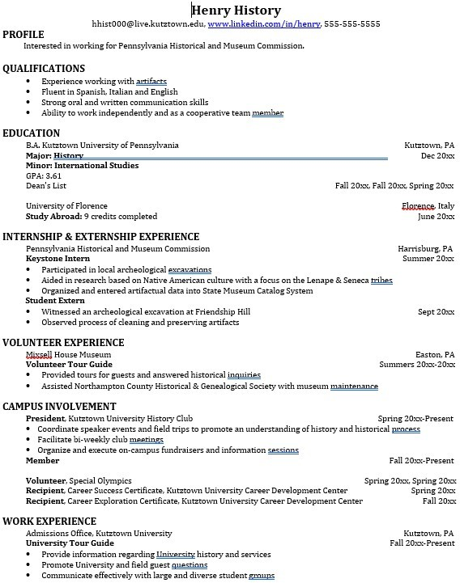
but also have experi-
Learn more about your field and develop the necessary skills for employment by gaining hands-on experience through internships.

For More Information on History careers or to speak to a Career Counselor, contact KU Career Development Center 113 Stratton Administration Center * 610-683-4067 * careerhelp@kutztown.edu * www.kutztown.edu/careercenter

