

Bachelor of Science: Geology Minor: Geology

Geology is a broad interdisciplinary science that involves the study of Earth and its history. Geologists gather and interpre t data about the Earth for the purpose of increasing our knowledge about natural resources and Earth processes. They provide basic information required for establishing policy for resource management and environmental protection. Geologists may explore for new mineral or oil resources, work on environmental problems, do research, or teach and often divide their time between work in the field, the laboratory, and the office.

The Bachelor of Science in Geology program at KU was designed to prepare students with enough fundamental understanding of geology to succeed in graduate school, and to provide the practical field experience needed to succeed as career geologists. Course requirements parallel the subjects on the Professional Geologist licensing exam. Employers recommend one or more internships to be successful and competitive when entering this field.

Career types associated with Geology
(Is this a good fit for you? Are you a…)
- Investigative - “Thinker”
- Realistic - “Doer”
- Social - “Helper”

Related skills, values, and qualities
- Proficiency in reading, writing, thinking, questioning, analyzing and problem solving
- Ability to conduct and explain scientific research
- Good manual dexterity and ability to operate scientific equipment
- Ability to make appropriate decisions and solve quantitative problems
- Aptitude for accuracy and detail
- Proficiency with computers
- Ability to work with people of varied backgrounds

Courses Geology majors typically enjoy
- Biology
- Earth Science
- Economics
- Geography
- Social Sciences

Common interests of Geology majors
- Visiting science museums, nature centers, or zoos
- Developing hobbies and collections related to soils, rocks, coins, or other artifacts
- Hiking, mountain climbing, camping, backpacking and other outdoors activities
- Exploring and traveling
- Playing games of strategy or putting together or solving puzzles
- Participating in Geology or science related clubs
- Reading science articles

For more information about the major Contact the Physical Sciences Department, 425 Boehm, 610-683-4447, or visit www.kutztown.edu/Geology

KU Majors related to Geology
Environmental Science, Geography, Marine Science

Investigative students may also be interested in: Anthropology, Biochemistry, Biology, Chemistry, Computer Science, Criminal Justice, Economics*, German Studies, History, International Studies*, Mathematics, Multicultural Studies*, PA German Studies*, Physics, Political Science, Psychology, Sec Edu- Math/Science, Sociology, Spanish, and Women’s Studies*
* minor only

For More Information on Geology careers or to speak to a Career Counselor, contact KU Career Development Center 113 Stratton Administration Center * 610-683-4067 * careerhelp@kutztown.edu * www.kutztown.edu/careercenter



- Enroll in the Career Exploration Certificate.
- Attend info sessions to learn about career development and personal branding.
- Take a career assessment to
identify and confirm interests.
- Get involved in campus clubs and organizations.
- Develop basic workplace skills through jobs or volunteer work.
- Talk with professors, family, and friends about career ideas.
- Conduct informational interviews with professionals working in fields of interest.
- Develop a relationship with your professors and faculty advisor.
- Meet with CDC career coach.
- Attend info sessions to learn about resume writing, and externships.
- Confirm your choice of major and consider options for double major or minor.
- Research careers of interest.
- Complete a job shadowing (externship) experience.
- Seek meaningful employ-ment or volunteer work in a field related to your major.
- Explore options for under-graduate research and study abroad.
- Write a resume and have it reviewed by the CDC.
- Manage your online presence.
- Enroll in the Career Success Certificate.
- Complete an internship and/or undergraduate research.
- Attend info sessions about internships, interviewing, job search strategies, and grad school.
- Build a LinkedIn profile and continue to monitor your online presence.
- Complete a mock interview.
- Build skills through research projects, part-time employment, and volunteer work.
- Participate in employment pan-els, site visits & networking events.
- Attend internship & job fairs.
- Take on a leadership role in a student organization or work.
- Consider graduate school
options and prepare for
- Attend your Senior Kick-off and other info sessions to prepare for job search/grad school.
- Update your resume and LinkedIn profile.
- Create cover letter drafts.
- Gain experience through internships and/or undergraduate research.
- Secure references for job/grad school applications.
- Create your “30 second”
commercial/elevator pitch.
- Meet with CDC to develop job search strategies.
- Research employers.
- Network with professionals through events and social media.
- Join a professional organization in your discipline.
- Attend the senior etiquette
luncheon or dinner.
- Participate in job fairs and on-campus interviewing.

Sample Career Titles
Geology majors can be found working in a wide variety of career fields. Here are just some career titles that may be of interest. Please note that some jobs may require further education and training.
To learn more about these careers, visit http://online.onetcenter.org or www.bls.gov/oco.

  - Agricultural Engineer
  - Agriculture Consultant
  - Architect
  - Astronomer
  - Cartographer
  - Computer Analyst
  - Economic Geologist
  - Environmental Consultant
  - Environmental Geologist
  - Environmental Lawyer
  - Forest Ranger
  - General Manager: Petroleum or Mining Company
  - Geochemist
  - Geodynamacist
  - Geologist
  - Geomorphologist
  - Geophysicist
  - Geophysics Technician
  - Geo-Technical Engineer
  - Glacial Geologist
  - Hydrologist
  - Industrial Hygienist
  - Instrumentation Technician
  - Laboratory Technician
  - Marine Advisor
  - Materials Analyst
  - Mathematician
  - Meteorologist
  - Mineralogist
  - Mining Engineer
  - National Park Service Professional
  - Oceanographer
  - Paleoceanographer
  - Paleoclimatologist
  - Paleontologist
  - Park Naturalist/Ranger
  - Peace Corps Worker
  - Petroleum Engineer
  - Petroleum Geologist
  - Petrologist
  - Planetary Geologist
  - Pollution Control Specialist
  - Pollution Remediator
  - Project Manager
  - Prospector
  - Sales Engineer
  - Sedimentologist
  - Seismologist
  - Soil Scientist
  - Stratigrapher
  - Structural Geologist
  - Surveyor
  - Technical Writer/Communicator
  - Urban/Regional Planner
  - US Foreign Service Worker
  - Volcanologist
  - Waste Management Specialist
  - Water Quality Control Technician
  - Water Remote Sensing Specialist
  - Well Logging Specialist

Common Internship Sites and Employers
Geology majors often find internships and employment in the following fields/industries.

- Colleges/Universities
- Construction Companies
- Consulting Firms
- Energy Companies
- Engineering Firms
- Marketing & Research Firms
- Mining Companies
- Petroleum Companies
- Railroads
- Research Laboratories
- State/Federal Government



Handshake is the primary online resource
for preparing and connecting students and alumni with employers.
www.kutztown.edu/handshake

Useful Websites for Geology Majors
Whether you are researching related career fields, applying for internships or jobs, or planning to join a professional association, these websites are for you!

Industry/Employment Information

American Geophysical Union www.agu.org

Careers in Federal Government www.makingthedifference.org
Environmental Careers World Job Bank
www.environmentaljobs.com

National Park Service www.nps.gov
New Scientist Jobs www.newscientistjobs.com

Science Careers http://sciencecareers.sciencemag.org
USGS Coastal and Marine Geology Program
http://marine.usgs.gov
LinkdedIn Jobs www.linkedin.com/jobs

Professional Associations

American Geological Institute www.americangeosciences.org

American Water Resources Association www.awra.org
Association for Environmental Studies
and Sciences https://aessonline.org
Geological Society of America www.geosociety.org

National Association of Environmental Professionals
www.naep.org
National Recreation & Park Association www.nrpa.org

North American Association for Environmental Education www.naaee.org

Related Area Employers

Earth Engineering
Environmental Strategy Consultants Geo-Technology Associates, Inc.
Heritage Conservancy Langan Engineering Maine Drilling & Blasting
National Park Service - Valley Forge
Oak Ridge Institute Pennsylvania Department of
Conservation and Natural Resources
Terraphase Engineering
U.S. Environmental Protection Agency Wildlands Conservancy

Building Your Resume for a Career in Geology

Building a strong resume for your career field starts long before you ever start your job search. Employers want to hire graduates who not only have the necessary educational background but also have experience applying that knowledge.

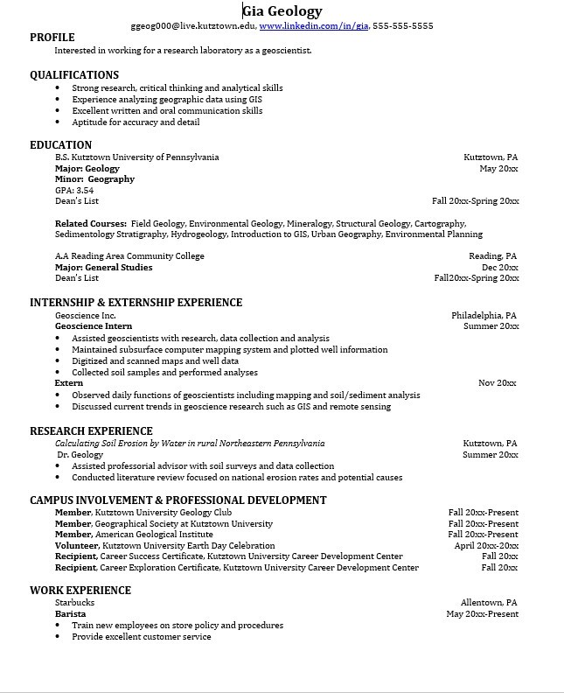
Learn more about your field and develop the necessary skills for employment by gaining hands-on experience through internships.

Utilize summer breaks to acquire valuable experience via volunteer or employment opportunities related to your major.

Develop professionally through campus involvement and professional memberships.
This illustrates responsibility, leadership abilities and time management skills.

For More Information on Geology careers or to speak to a Career Counselor, contact KU Career Development Center 113 Stratton Administration Center * 610-683-4067 * careerhelp@kutztown.edu * www.kutztown.edu/careercenter

