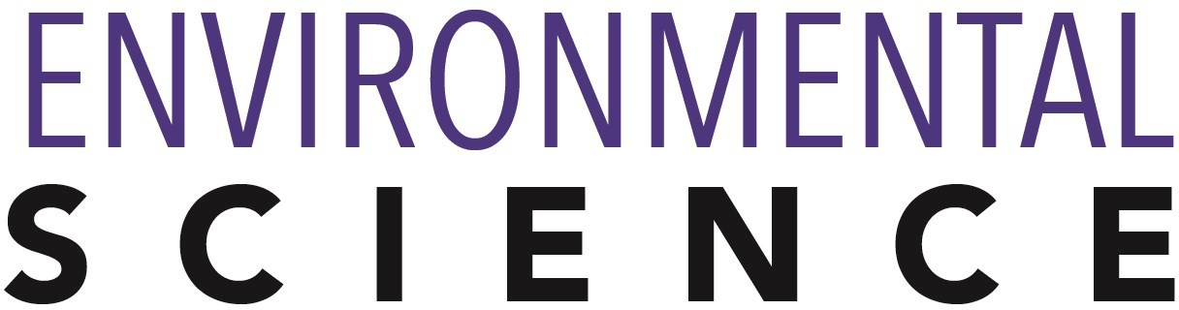

Bachelor of Science: Environmental Science/ Biology Bachelor of Science: Environmental Science/ Chemistry Bachelor of Science: Environmental Science/ Geography Bachelor of Science: Environmental Science/ Geology
Bachelor of Science: Environmental Science/Regenerative Agriculture

The Bachelor of Science program in Environmental Science provides specialized training to prepare students to obtain employment as environmental scientists or for graduate studies in the natural or environmental sciences. The Environmental Science Program is an interdisciplinary program with a curriculum that is designed to provide students the opportunity to specialize in biology, chemistry, geography, or geology. Students in the Environmental Science Program are encouraged to pursue internships for course credit and to conduct research projects using the specialized facilities and equipment available at KU. Employers recommend one or more internships to be successful and competitive when entering this field.

Career types associated with Environmental Science
(Is this a good fit for you? Are you a…)
- Investigative - “Thinker”
- Enterprising - “Leader”
- Realistic - “Doer”

Related skills, values, and qualities
- Proficiency in reading, writing, thinking, questioning, analyzing and problem solving
- Ability to organize, analyze & interpret scientific research
- Ability to make critical observations & appropriate decisions
- Good manual dexterity and ability to operate scientific equipment
- Aptitude for accuracy and detail
- Ability to conduct and explain scientific research

Courses Environmental Science majors typically enjoy
- Biology
- Earth Science
- Economics
- Geography
- Social Sciences

Common interests of Environmental Science majors
- Attending science exhibits, visiting nature centers, zoos or museums
- Participating in environmental and/or science clubs
- Hiking, camping, backpacking and other outdoor activities
- Working part-time or volunteering in their community.
- Watching programs about the environment.

For more information about the major Contact the Physical Sciences Department, 425 Boehm, 610-683-4447, or visit www.kutztown.edu/EnvironmentalScience

KU Majors related to Environmental Science Biology, Chemistry, Geology, Geography, Marine Science, Secondary Education– Science

Investigative students may also be interested in: Anthropology, Biochemistry, Computer Science, Criminal Justice, Economics*, German Studies, History, International Studies*, Mathematics, Multicultural Studies*, PA German Studies*, Physics, Political Science, Psychology, Sociology, Spanish, and
Women’s Studies*
* minor only

For More Information on Environmental Science careers or to speak to a Career Counselor, contact KU Career Development Center 113 Stratton Administration Center * 610-683-4067 * careerhelp@kutztown.edu * www.kutztown.edu/careercenter



- Enroll in the Career Exploration Certificate.
- Attend info sessions to learn about career development and personal branding.
- Take a career assessment to
identify and confirm interests.
- Get involved in campus clubs and organizations.
- Develop basic workplace skills through jobs or volunteer work.
- Talk with professors, family, and friends about career ideas.
- Conduct informational interviews with professionals working in fields of interest.
- Develop a relationship with your professors and faculty advisor.
- Meet with CDC career coach.
- Attend info sessions to learn about resume writing, and externships.
- Confirm your choice of major and consider options for double major or minor.
- Research careers of interest.
- Complete a job shadowing (externship) experience.
- Seek meaningful employ-ment or volunteer work in a field related to your major.
- Explore options for under-graduate research and study abroad.
- Write a resume and have it reviewed by the CDC.
- Manage your online presence.
- Enroll in the Career Success Certificate.
- Complete an internship and/or undergraduate research.
- Attend info sessions about internships, interviewing, job search strategies, and grad school.
- Build a LinkedIn profile and continue to monitor your online presence.
- Complete a mock interview.
- Build skills through research projects, part-time employment, and volunteer work.
- Participate in employment panels, site visits & networking programs.
- Attend internship & job fairs.
- Take on a leadership role in a student organization or work.
- Consider graduate school
options and prepare for

- Attend your Senior Kick-off and other info sessions to prepare for job search/grad school.
- Update your resume and LinkedIn profile.
- Create cover letter drafts.
- Gain experience through internships and/or undergraduate research.
- Secure references for job/grad school applications.
- Create your “30 second”
commercial/elevator pitch.
- Meet with CDC to develop job search strategies.
- Research employers.
- Network with professionals through events and social media.
- Join a professional organization in your discipline.
- Attend the senior etiquette
luncheon or dinner.
- Participate in job fairs and on-campus interviewing.

Sample Career Titles
Environmental Science majors can be found working in a wide variety of career fields. Here are just some career titles that may be of interest. Please note that some jobs may require further education and training.
To learn more about these careers, visit http://online.onetcenter.org or www.bls.gov/oco.

  - Agronomist
  - Air And Water Quality Manager
  - Air Pollution Analyst
  - Biochemist
  - Biologist
  - Biomedical Engineer
  - Biotechnologist
  - Chemical Technician
  - Chemist
  - City Planner
  - Civil Engineer
  - Conservation Scientist
  - Conservation Systems Analyst
  - Consumer Safety Inspector
  - Earth Scientist
  - Ecologist
  - Engineering Technician
  - Environmental Analyst
  - Environmental Consultant
  - Environmental Engineer
  - Environmental Planner
  - Environmental Health Specialist
  - Environmental Lawyer
  - Environmental Lobbyist
  - EPA Inspector
  - EPA Statistician
  - Fisheries Conservationist
  - Farm Manager
  - Food Scientist
  - Forest Ranger
  - Forester
  - Geographer
  - Geologist
  - Geophysicist
  - Greenhouse Manager
  - Hazardous Waste Manager
  - Hemp Sales Manager
  - Hydrologist
  - Industrial Hygienist
  - Management Consultant
    - Meteorologist
    - Microbiologist
    - Natural Resource Specialist
    - Natural Resources Conservationist
    - Occupational Safety Specialist
    - Ocean Technician
    - Oceanographer
    - Outdoor Trip Leader
    - Park Ranger
    - Pharmacy Technician
    - Project Manager
    - Public Health Veterinarian
    - Range Manager
    - Resource Economist
    - Seismologist
    - Soil Conservation Technician
    - Teacher
    - Urban And Regional Planner
    - Water/Wastewater Plant Operator
    - Wildlife Manager/Zoologist

Common Internship Sites and Employers
Environmental Science majors often find internships and employment in the following fields/industries.

- Book/Journal Publishers
- Business and Industry
- College/Universities
- Environmental Consulting Firms
- Laboratories
- Non-Profit Organizations
- Park Systems/Nature Preserves
- Pharmaceutical Companies
- State/Federal Government



Handshake is the primary online resource
for preparing and connecting students and alumni with employers.
www.kutztown.edu/handshake

Useful Websites for Environmental Science Majors
Whether you are researching related career fields, applying for internships or jobs, or planning to join a professional association, these websites are for you!

Industry/Employment Information

Earth Magazine www.earthmagazine.org

Environmental Protection Agency www.epa.gov
Careers in Federal Government
www.makingthedifference.org

Natural Resources Job Search www.cyber-sierra.com/nrjobs
Student Conservation Association, Inc. www.thesca.org

Job/Internship Search Sites
Federal Careers www.usajobs.gov

EcoEmploy www.ecoemploy.com

EnviroLink www.envirolink.org

Environmental Careers World Job Bank www.environmentaljobs.com
New Scientist Jobs www.newscientistjobs.com
LinkedIn Jobs www.linkedin.com/jobs

Professional Associations
American Water Resources Association
www.awra.org
Association for Environmental Studies and Sciences https://aessonline.org

Ecological Society of America
www.esa.org
North American Association for Environmental Education www.naaee.org

National Environmental Health Association
www.neha.org
National Association of Environmental Professionals www.naep.org

National Recreation & Park
Association
www.nrpa.org

Related Area Employers
Alliance for Sustainable Communities - Lehigh Valley, Appalachian Trail Conservancy, Barry Isett & Associates, Inc., Berks Nature, Bowman's Hill Wildflower Preserve, City of Reading Public Works/Sustainability & Solid Waste, City of Philadelphia, East Penn Manufacturing, Gateway National Recreation Area, Giorgi Companies, Hawk Mountain Sanctuary, Heritage Conservancy, Hopewell National Park, Lehigh Gap Nature Center, Lehigh Valley Zoo, Longwood Gardens, Monroe County Conservation District, PACE Environmental, Pennsylvania Department of Conservation and Natural Resources, Pennsylvania Department of Environmental Protection, Philadelphia Zoo, Rodale Institute, Suburban Testing Labs , U.S. Army Corps of Engineers Blue Marsh Lake, Valley Forge National Park, Wildlands Conservancy

Building Your Resume for a Career in Environmental Science

Develop professionally through campus involvement and professional memberships.
This illustrates responsibility, leadership abilities and time management skills.

Utilize summer breaks to acquire valuable experience via volunteer or employment opportunities related to your major.

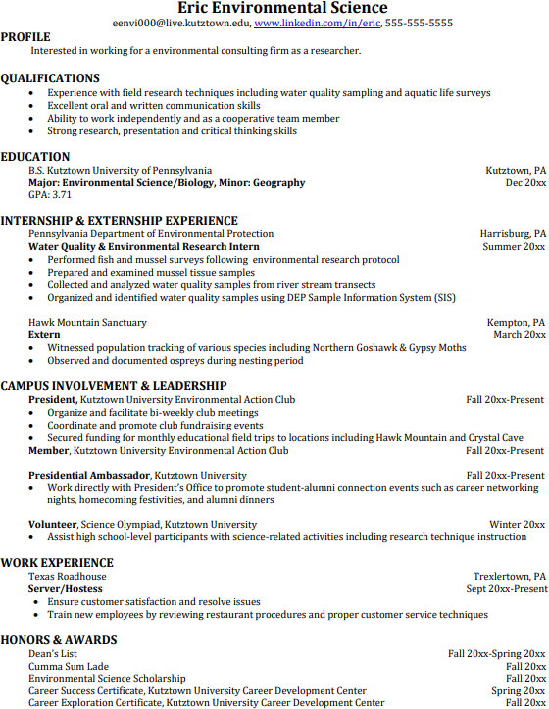
Building a strong resume for your career field starts long before you ever start your job search. Employers want to hire graduates who not only have the necessary educational background but also have experience applying that knowledge.
Learn more about your field and develop the necessary skills for employment by gaining hands-on experience through internships.

For More Information on Environmental Science careers or to speak to a Career Counselor, contact KU Career Development Center 113 Stratton Administration Center * 610-683-4067 * careerhelp@kutztown.edu * www.kutztown.edu/careercenter

