

Bachelor of Science: Biology/Molecular, Micro, and Cell
Bachelor of Science: Biology/ Pre-Medical and Other Health Careers Bachelor of Science: Biology/Organismal/Ecology
Bachelor of Science: Biology/Allied Health Minor: Biology
Certificate: Biotechnology

Biology is the study of the science of life in all its forms. The KU Biology programs help students to develop an appreciation for and knowledge of fundamental biological principles, develop skills in biological techniques, and prepare for employment and graduate, medical, or other professional schools. The programs have strong lab components that emphasize student involvement and close student-faculty interaction. Employers recommend one or more research experience and/or internships to be successful and competitive when entering this field.

Career types associated with Biology
(Is this a good fit for you? Are you a…)
- Investigative - “Thinker”
- Artistic - “Creative”
- Realistic - “Doer”

Related skills, values, and qualities
- Proficiency in reading, writing, thinking, questioning, analyzing and problem solving
- Ability to make critical observations and appropriate decisions
- Good manual dexterity and ability to operate scientific equipment
- Aptitude for accuracy and detail
- Ability to organize and maintain accurate records
- Ability to conduct and explain scientific research
- Ability to concentrate for long periods of time
- Knowledge of basic biological principles
- Patience

Courses Biology majors typically enjoy
- Biology
- Chemistry
- Environmental Science
- Health/Nutrition
- Physiology
- Zoology

Common interests of Biology majors
- Attending science exhibits and visiting nature centers, zoos or museums
- Conducting research and participating in science fairs and competitions
- Participating in conservation, recycling, health, and
science-related clubs and organizations
- Working part-time or volunteering in a greenhouse, nursery, animal sanctuary, hospital, veterinary clinic, or with an environmental conservation organization
- Reading science and health/fitness magazines, books and other publications

For more information about the major
Contact the Biology Department, 223 Boehm,
610-683-4307 or visit www.kutztown.edu/Biology

KU Majors related to Biology
Biochemistry, Chemistry, Environmental Science, and Marine Biology, Secondary Education– Science

Investigative students may also be interested in: Anthropology, Computer Science, Criminal Justice, Economics*, Geography, Geology, German Studies, History, International Studies*, Mathematics, Multicultural Studies*, PA German Studies*, Physics, Political Science, Psychology, Sociology, Spanish,
and Women’s Studies*
* minor only

For More Information on Biology careers or to speak to a Career Counselor, contact KU Career Development Center 113 Stratton Administration Center * 610-683-4067 * careerhelp@kutztown.edu * www.kutztown.edu/careercenter



- Enroll in the Career Exploration Certificate.
- Attend info sessions to learn about career development and personal branding.
- Take a career assessment to
identify and confirm interests.
- Get involved in campus clubs and organizations.
- Develop basic workplace skills through jobs or volunteer work.
- Talk with professors, family, and friends about career ideas.
- Conduct informational interviews with professionals working in fields of interest.
- Develop a relationship with your professors and faculty advisor.
- Meet with CDC career coach.
- Attend info sessions to learn about resume writing, and externships.
- Confirm your choice of major and consider options for double major or minor.
- Research careers of interest.
- Complete a job shadowing (externship) experience.
- Seek meaningful employ-ment or volunteer work in a field related to your major.
- Explore options for under-graduate research and study abroad.
- Write a resume and have it reviewed by the CDC.
- Manage your online presence.
- Enroll in the Career Success Certificate.
- Complete an internship and/or undergraduate research.
- Attend info sessions about internships, interviewing, job search strategies, and grad school.
- Build a LinkedIn profile and continue to monitor your online presence.
- Complete a mock interview.
- Build skills through research projects, part-time employment, and volunteer work.
- Participate in employer panels, site visits & networking events.
- Attend internship & job fairs.
- Take on a leadership role in a student organization or work.
- Consider graduate school options and prepare for admissions tests.
- Attend your Senior Kick-off and other info sessions to prepare for job search/grad school.
- Update your resume and LinkedIn profile.
- Create cover letter drafts.
- Gain experience through internships and/or undergraduate research.
- Secure references for job/grad school applications.
- Create your “30 second”
commercial/elevator pitch.
- Meet with CDC to develop job search strategies.
- Research employers.
- Network with professionals through events and social media.
- Join a professional organization in your discipline.
- Attend the senior etiquette
luncheon or dinner.
- Participate in job fairs and on-campus interviewing.

Sample Career Titles
Biology majors can be found working in a wide variety of career fields. Here are just some career titles that may be of interest. Please note that some jobs may require further education and training.
To learn more about these careers, visit http://online.onetcenter.org or www.bls.gov/oco.

  - Animal Scientist
  - Aquaculture Farmer
  - Aquaculturist
  - Aquarium & Museum Worker
  - Aquarium Technician
  - Aquatic Biologist
  - Barrier Beach Manager
  - Biochemist
  - Bio-Engineer
  - Biometrician
  - Bio-Technologist
  - Bioterrorism Expert
  - Botanist
  - Brewery Laboratorian
  - Coastal Resources Worker
  - College Professor
  - Commercial Fishing Engineer
  - Commercial Inland Water
  - Coroner
  - Dentist
  - Dietitian & Nutritionist
  - Ecologist
  - Ergonomist
  - Fisheries Conservationist
  - Forester
  - Funeral Director
  - Genetic Engineering Researcher
  - Health Officer
  - Horticulturist
  - Hospital Administrator
  - Hydrographic Survey Technician
  - Industrial Hygienist
  - Limnological Technician
  - Marine Bacteriologist/Biologists
  - Marine Fisheries Worker
  - Marine Geologist/Geophysicist/ Physicist
  - Marine Tourist Worker
  - Medical Librarian
  - Medical Technologist
  - Merchant Marine
  - Meteorologist
  - Microbiologist Mining & Petroleum Industry Worker
  - Museum/Aquarium Administrator
  - Mycologist
  - Neurobiologist
  - Pharmaceutical Salesperson
  - Pharmacist
  - Physical Therapist
  - Physician
  - Public Health Worker
  - Research Assistant
  - Science Laboratory Technician
  - Science Teacher
  - Seafood Processor-Researcher
  - State Parks & Recreation Worker
  - Test and Inspection Technician
  - Toxicologist
  - Underwater Technician
  - Veterinarian
  - Water Quality Technician
  - Wildlife Biologist
  - Wildlife Resources Worker

Common Internship Sites and Employers
Biology majors often find internships and employment in the following fields/industries.

- Agricultural Chemical Companies
- Biological Book/Journal Publishers
- Biological Testing Laboratories
- Business and Industry
- College/Universities
- Consulting Engineering Firms
- Ecological Organizations
- Hospitals/Medical Centers
- Medical Corporations
- Pharmaceutical Companies
- State/Federal Government



Handshake is the primary online resource
for preparing and connecting students and alumni with employers.
www.kutztown.edu/handshake

Useful Websites for Biology Majors
Whether you are researching related career fields, applying for internships or jobs, or planning to join a professional association, these websites are for you!

Industry/Employment Information

BioPharmGuy http://biopharmguy.com

Biotechnology Industry Organization www.bio.org

Careers in Biology
www.sicb.org/jobs-and-fellowships/

Environmental Careers World Job Bank www.environmentaljobs.com

Medical Jobs www.medicaljobs.org
Science Careers www.sciencecareers.org
Professional Associations

American Institute of Biological Sciences www.aibs.org

American Association for the Advancement of Science
www.aaas.org
American Society for Biochemistry and
Molecular Biology
www.asbmb.org

American Chemical Society www.ascb.org

American Society for Microbiology www.asm.org

Biotechnology Industry Organization www.bio.org

Counsel for the Advancement of Sci. Writing www.casw.org
The National Academies www.nas.edu
Related Area Employers

Actalent Aptagen
B. Braun Berks Nature
DaVinci Science Center East Penn Manufacturing Eurofins Scientific GlaxoSmithKline
Hawk Mountain Sanctuary Health Network Laboratories Johnson & Johnson
Lehigh Valley Health Network Lehigh Valley Zoo
Mainline Health Merck & Co., Inc.
Northumberland County Conservation District
Olympus Corporation
Patt Veterinary Associates LLC Penn State Hershey Medical Center Pfizer, Inc.
St. Luke’s Health Network
Teva Pharmaceuticals
Tower Health Reading Hospital Wildlands Conservancy

Building Your Resume for a Career in Biology

Develop professionally through campus involvement and professional memberships.
This illustrates responsibility, leadership abilities and time management skills.
Utilize summer breaks to acquire valuable experience via volunteer or employment opportunities related to your major.

Building a strong resume for your career field starts long before you ever start your job search. Employers want to hire graduates who not only have the necessary educational background
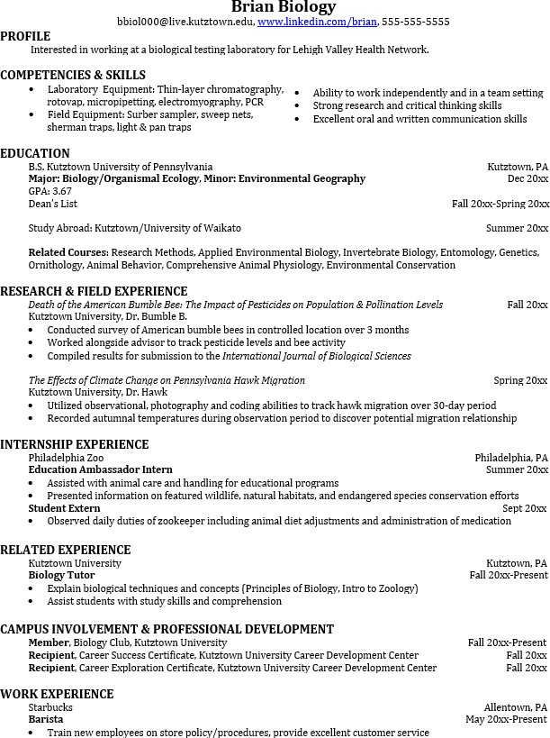
but also have experience applying that knowledge.

Learn more about your field and develop the necessary skills for employment by gaining hands-on experience through internships & related experiences.

For More Information on Biology careers or to speak to a Career Counselor, contact KU Career Development Center 113 Stratton Administration Center * 610-683-4067 * careerhelp@kutztown.edu * www.kutztown.edu/careercenter

