

Bachelor of Science: Biochemistry Track: Pharmacy
Minor: Biochemistry Certificate: Biotechnology

Biochemistry is the study of the chemistry of life: the molecules and chemical reactions that underlie living processes. The KU Biochemistry program provides extensive hands-on laboratory experience to develop the skills required for industry and graduate school. Biochemistry majors may go on to have careers in a variety of industries, research laboratories, healthcare and government agencies. Graduates may find employment doing laboratory work, assisting on a research team, working in product development, or may work in the business-related areas of plant management, marketing or sales. Further study can be pursued in graduate or medical school. Employers recommend one or more internships to be successful and competitive when entering this field.

Career types associated with Biochemistry
(Is this a good fit for you? Are you a…)
- Investigative - “Thinker”
- Realistic - “Doer”
- Social - “Helper”

Related skills, values, and qualities
- Proficiency in reading, writing, thinking, questioning, analyzing and problem solving
- Ability to organize, analyze and interpret scientific research
- Strong math skills
- Proficiency with computers
- Good manual dexterity and ability to operate scientific equipment
- Aptitude for accuracy and detail
- Ability to conduct and explain scientific research

Courses Biochemistry majors typically enjoy
- Algebra, Trigonometry, Calculus
- Chemistry
- Computer Science
- Earth Science
- Geometry
- Physical Science

Common interests of Biochemistry majors
- Conducting research and participating in science fairs and competitions
- Attending science exhibits, museums, and demonstrations
- Participating in biology, chemistry or science clubs
- Working part-time or volunteering in a pharmacy, hospital, or with an environmental conservation organization
- Watching scientific programs
- Cooking
For more information about the major Contact the Physical Sciences Department, 425 Boehm, 610-683-4447 or visit www.kutztown.edu/ Biochemistry
KU Majors related to Biochemistry Biology, Chemistry, Marine Biology, Secondary Education– Science
Investigative students may also be interested in: Anthropology, Biology, Chemistry, Computer Science, Criminal Justice, Economics*, Environmental Science, Geography, Geology, German Studies, History, International Studies*, Marine Science, Mathematics, Multicultural Studies*, PA German Studies*, Physics, Political Science, Psychology,
Sociology, Spanish, and Women’s Studies*
* minor only

For More Information on Biochemistry careers or to speak to a Career Counselor, contact KU Career Development Center 113 Stratton Administration Center * 610-683-4067 * careerhelp@kutztown.edu * www.kutztown.edu/careercenter



- Enroll in the Career Exploration Certificate.
- Attend info sessions to learn about career development and personal branding.
- Take a career assessment to
identify and confirm interests.
- Get involved in campus clubs and organizations.
- Develop basic workplace skills through jobs or volunteer work.
- Talk with professors, family, and friends about career ideas.
- Conduct informational interviews with professionals working in fields of interest.
- Develop a relationship with your professors and faculty advisor.
- Meet with CDC career coach.
- Attend info sessions to learn about resume writing, and externships.
- Confirm your choice of major and consider options for double major or minor.
- Research careers of interest.
- Complete a job shadowing (externship) experience.
- Seek meaningful employ-ment or volunteer work in a field related to your major.
- Explore options for under-graduate research and study abroad.
- Write a resume and have it reviewed by the CDC.
- Manage your online presence.
- Enroll in the Career Success Certificate.
- Complete an internship and/or undergraduate research.
- Attend info sessions about internships, interviewing, job search strategies, and grad school.
- Build a LinkedIn profile and continue to monitor your online presence.
- Complete a mock interview.
- Build skills through research projects, part-time employment, and volunteer work.
- Participate in employer panels, site visits & networking events.
- Attend internship & job fairs.
- Take on a leadership role in a student organization or work.
- Consider graduate school options and prepare for admissions tests.
- Attend your Senior kick-off and other info sessions to prepare for job search/grad school.
- Update your resume and LinkedIn profile.
- Create cover letter drafts.
- Gain experience through internships and/or undergraduate research.
- Secure references for job/grad school applications.
- Create your “30 second”
commercial/elevator pitch.
- Meet with CDC to develop job search strategies.
- Research employers.
- Network with professionals through events and social media.
- Join a professional organization in your discipline.
- Attend the senior etiquette luncheon or dinner.
- Participate in job fairs and on-campus interviewing.

Sample Career Titles
Biochemistry majors can be found working in a wide variety of career fields. Here are just some career titles that may be of interest. Please note that some jobs may require further education and training.
To learn more about these careers, visit http://online.onetcenter.org or www.bls.gov/oco.

  - Agricultural Scientist
  - Agronomist
  - Anesthesiologist
  - Biochemist
  - Bioterrorism Expert
  - Cepalometric Analyst
  - Ceramic Engineer
  - Chemical Engineer
  - Chemical Oceanographer
  - Chemist
  - Chemistry Technologist
  - Clarifying Plant Operator
  - College/High School Teacher
  - Color Development Chemist
  - Consumer Protection Specialist
  - Crime Lab Analyst
  - Cytotechnologist
  - Data Scientist
  - Dietician
  - Environmental Health Specialist
  - Epidemiologists
  - Food and Drug Analyst
  - Forensic Chemist
  - Genetic Counselor
  - Geneticist
  - Hospital Administrator
  - Hydrologist
  - Industrial Health Engineer
  - Industrial Hygienist
  - Internist
  - Medical & Clinical Lab Technologist
  - Medical Librarian
  - Medical Scientists
  - Metallurgist
  - Molecular Biologist
  - Museum/Aquarium Administrator
  - Mycologist
  - Natural Science Managers
  - Nutritionist
  - Occupational Safety Specialist
  - Patent Examiner
  - Perfumer
  - Pharmaceutical Sales Rep.
  - Pharmacist
  - Pharmacologist
  - Physician
  - Physicist
  - Plastics Engineer
  - Product Tester
  - Quality Assurance Manager
  - Registered Nurse
  - Soil Scientist
  - System Analyst
  - Technical Writer
  - Technician
  - Tissue Technologist
  - Toxicologist
  - Veterinarian
  - Wastewater Treatment Chemist
  - Water Purification Specialist
  - Wildlife Biologist

Common Internship Sites and Employers
Biochemistry majors often find internships and employment in the following fields/industries.

- Technical Publishers
- Biological Testing Laboratories
- Chemical Companies
- Schools, Colleges, & Universities
- Food Companies/Administration
- Mining Companies
- Pharmaceutical Companies
- Research Organizations
- State & Federal Government
- Zoos & Ecological Organizations



Handshake is the primary online resource
for preparing and connecting students and alumni with employers.
www.kutztown.edu/handshake

Useful Websites for Biochemistry Majors
Whether you are researching related career fields, applying for internships or jobs, or planning to join a professional association, these websites are for you!

Industry/Employment Information
Careers in Federal Government https://ourpublicservice.org

Chemical Week Magazine www.chemweek.com

Journal of Chemical Education www.chemedx.org

Life Sciences World
www.lifesciencesworld.com
National Academies www.nas.edu

Pharma. Research & Manufacturing www.phrma.org

Job/Internship Search Sites
BioSpace www.biospace.com

BioPharmGuy http://biopharmguy.com

Chemistry Jobs chemistryjobs.com

Environmental Careers World Job Bank
www.environmentaljobs.com
Medical Jobs www.medicaljobs.org
New Scientist Jobs www.newscientistjobs.com
Science Careers www.sciencecareers.org
LinkedIn Jobs www.linkedin.com/jobs
Research Experience for Undergraduates
REU’s
https://new.nsf.gov/funding/opportunities/
research-experiences-undergraduates-reu

Professional Associations

American Academy of Forensic Science www.aafs.org

American Association for the Advancement of Science
www.aaas.org
American Assoc. of Clinical Chemistry www.aacc.org

American Chemical Society www.acs.org

American Institute of Chemists www.theaic.org

American Society for Biochemistry and Molecular Biology
www.asbmb.org

Biotechnology Industry Organization www.bio.org
Council for Chemical Research www.ccrhq.org

The National Academies
www.nas.edu

Related Area Employers
Actalent, Aptagen, BioSpectra, Borough of Kutztown Water Department, Carpenter Technology, DaVinci Science Center, East Penn Manufacturing, Eurofins Scientific, EnerSys, Environmental Protection Agency, International Flavors and Fragrances, Lehigh County Authority, Lubrizol Life Sciences, NSF-Research Experience for Undergraduates, Merck & Co., M.J. Reider Associates, Nestle Waters, Olympus Corporation, PA-Department of Environmental Pro-tection, Pfizer, Suburban Testing Labs, Teva Pharmaceuticals, Quaker Chemical, VWR, Wacker Chemical

Building Your Resume for a Career in Biochemistry

Develop professionally through campus involvement and professional memberships.
This illustrates responsibility, leadership abilities and time management skills.
Utilize summer breaks to acquire valuable experience via volunteer or employment opportunities related to your major.

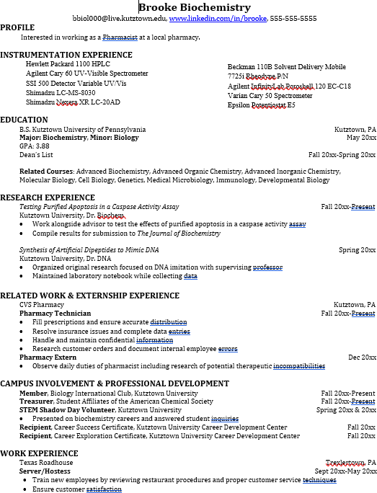
Building a strong resume for your career field starts long before you ever start your job search. Employers want to hire graduates who not only have the necessary educational background but also have experience applying that knowledge.

Learn more about your field and develop the necessary skills for employment by gaining hands-on experience through internships & related experiences.

For More Information on Biochemistry careers or to speak to a Career Counselor, contact KU Career Development Center 113 Stratton Administration Center * 610-683-4067 * careerhelp@kutztown.edu * www.kutztown.edu/careercenter

