Bachelor of Science in Business Administration with a major in Marketing
The Marketing major offers students the ability to study all areas of business and organization structures that have direct impact on customer satisfaction and excitement and will prepare you for many different and rewarding career paths.
Marketing graduates work in Marketing Research, Marketing, Communications, E-Commerce, Advertising, Sales and Sales Management, Transportation and Distribution, Retailing, Buying, Merchandising, Product Development and Management and many other areas, on local, regional, national and international levels. Because the Marketing major works with diverse stakeholders across a broad spectrum of functional areas, careers are rarely dull and always challenging. To differentiate yourself in the competitive job market, employers recommend that students should complete one or more internships.

Career themes associated with Marketing
(Is this a good fit for you? Are you a…)
- Enterprising - “Persuader”
- Social - “Helper”
- Realistic - “Doer”

Related skills, values, and qualities
- Ability to organize, plan, persuade, sell,
and coordinate activities
- Ability to communicate ideas and concepts to others
- Strong interpersonal and networking skills
- Proficiency in reading, writing and speaking
- Ability to solve problems and make effective decisions
- Ability to think creatively
- Aptitude for leadership
- Strong sense of integrity and professionalism

Courses Marketing majors typically enjoy
- Accounting
- Business
- Business Law
- Economics
- Management
- Psychology
- Sociology
- Speech
- Writing

Common interests of Marketing majors
- Working part-time in an advertising firm, or wholesale/retail establishment
- Participating in oratory contests or on a debate or forensic team
- Attending auctions, political rallies, or sales lectures
- Participating in a civic fund-raising event or in student government
- Volunteering to write/design promotional materials
- Reading publications related to marketing and distribution
- Attending sales/marketing workshops and conferences
For more information about the major Contact the Department of Business Administration, 236 deFrancesco, 610-683-4580

KU Majors related to Marketing
Communication Design, Communication Studies, English Professional Writing, Management, Public Administration, Sport Management, Psychology, Sociology
Enterprising students may also be interested in: Advertising*, Criminal Justice, Economics*, Education, Finance, International Studies*, Library Science, Literature*, Multicultural Studies*, Political Science, Public Relations*, Social Work, Writing*
*minor only



For More Information on Marketing Careers or to speak to a Career Counseling, contact KU Career Development Center 113 Stratton Administration Center * 610-683-4067 * careerhelp@kutztown.edu * www.kutztown.edu/careercenter



  - Enroll in the Career Exploration Certificate.
  - Attend info sessions to learn about career development and personal branding.
  - Take a career assessment to identify and confirm interests.
  - Get involved in campus clubs
and organizations.
  - Develop basic workplace skills through jobs or volunteer work.
  - Talk with professors, family, and friends about career ideas.
  - Conduct informational interviews with professionals working in fields of interest.
  - Develop a relationship with your professors and faculty advisor.
- Meet with CDC career coach.
- Attend info sessions to learn about resume writing, and externships.
- Confirm your choice of major and consider options for double major or minor.
- Research careers of interest.
- Complete a job shadowing (externship) experience.
- Seek meaningful employ-ment or volunteer work in a field related to your major.
- Explore options for under-graduate research and study abroad.
- Write a resume and have it reviewed by the CDC.
- Manage your online presence.
- Enroll in the Career Success Certificate.
- Complete an internship and/ or undergraduate research.
- Attend info sessions about internships, interviewing, job search strategies, and grad school.
- Build a LinkedIn profile and continue to monitor your online presence.
- Complete a mock interview.
- Build skills through research projects, part-time employ-ment, and volunteer work.
- Participate in employers pan-els, site visits & networking events.
- Attend internship & job fairs.
- Take on a leadership role in a student organization or work.
- Consider graduate school options and prepare for admissions tests.
- Attend your Senior Kick-off and other info sessions to prepare for job search/grad school.
- Update your resume and LinkedIn profile.
- Create cover letter drafts.
- Gain experience through internships and/or undergraduate research.
- Secure references for job/grad school applications.
- Create your “30 second”
commercial/elevator pitch
- Meet with CDC to develop job search strategies.
- Research employers.
- Network with professionals through events and social media.
- Join a professional organization in your discipline.
- Attend the senior etiquette
luncheon or dinner.
- Participate in job fairs and on-campus interviewing.

Sample Career Titles
Marketing majors can be found working in a wide variety of career fields. Here are just some career titles that may be of interest. Please note that some jobs may require further education and training.

  - Account Manager
  - Advertising Executive
  - Advertising Space Salesperson
  - Art Director
  - Bank Officer
  - Brand Manager
  - Buyer
  - Circulation Manager
  - Commercial Artist
  - Comparison Shopper
  - Consultant
  - Consumer Affairs Specialist
  - Consumer Credit/Loan Officer
  - Copywriter
  - Customer Service Manager
  - Development Officer
  - Direct Sales Person
  - Director of Marketing
  - Distribution Manager
  - Franchise Specialist
  - Fundraiser
  - Government Administrator
  - Import/Export Manager
  - Insurance Agent
  - International Marketer
  - Internet Marketing Specialist
  - Inventory Control Specialist
  - Lobbyist
  - Manufacturer Sales Representative
  - Market Representative
  - Market Research Analyst
  - Market Research Interviewer
  - Marketing Field Coordinator
  - Marketing Planner/Researcher
  - Media Buyer/Analyst
  - Merchandising Manager
  - Non-Profit Organization Manager
  - Online Marketer
  - Pharmaceutical Sales Representative
  - Product Analyst
  - Product Manager
  - Promotions Director
  - Property Manager
  - Public Relations Manager
  - Purchasing Agent
  - Real Estate Agent
  - Research Analyst
  - Retail Sales Associate
  - Retail Manager
  - Sales Agent
  - Sales Manager
  - Sales Promotion Manager
  - Securities Sales Agent
  - Specialty Advertising Distributor
  - Sports/Special Events Executive
  - Store Manager
  - Telecommunications Director

To learn more about these careers, visit http://online.onetcenter.org or www.bls.gov/oco.

Common Internship Sites and Employers
Marketing majors often find internships and employment in the following industries:

    - Advertising Agencies
    - Consumer Product Companies
    - Government
    - Healthcare Industry
    - Higher Education
    - Insurance & Financial Industry
    - Manufacturing Companies
    - Non-Profit Organizations
    - Pharmaceutical Companies
      - Publishing Companies
      - Retail and Hospitality Industry
      - Radio/Television Stations
      - Sports & Entertainment Industry



Handshake is the primary online resource
for preparing and connecting students and alumni with
employers. www.kutztown.edu/handshake

Useful Websites for Marketing Majors
Whether you are researching related career fields, applying for internships or jobs, or planning to join a professional association, these websites are for you!

Industry/Employment Information

Advertising Age www.adage.com

Marketing Jobs www.marketingjobs.com
LaSalle Non-Profit Center www.lasallenonprofitcenter.org
LinkedIn Jobs www.linkedin.com/jobs

Professional Associations
American Marketing Association
www.ama.org

American Advertising Federation www.aaf.org
Business Marketing Association www.marketing.org

E-marketing Association www.emarketingassociation.com

Marketing Research Association www.insightsassociation.org
Sales and Marketing Executives
International
www.smei.org
Society for Marketing Professional Services
www.smps.org

Related Area Employers
Altitude Marketing APR Supply Co ArtsQuest
Brenntag North America Brentwood Industries Clark Associates
DaBrian Marketing Group East Penn Manufacturing Elysium Marketing Group
Hershey Entertainment & Resorts Historic Bethlehem Museum & Sites Klunk & Millan Advertising
Liquid Interactive
Ritter Insurance Marketing Sherwin Williams
Sorrelli Jewelry Strunk Media Group webCemeteries WebFX

Building Your Resume for a Career in Marketing
Learn more about your field and develop the necessary skills for employment by gaining hands-on experience through externships, internships, part-time jobs and related
volunteer positions.
Develop professionally through campus involvement and professional memberships.
This illustrates responsibility, leadership abilities and time management
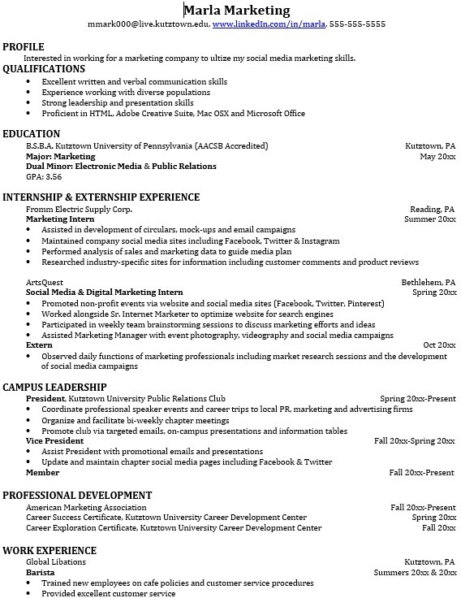
Building a strong resume for your career field starts long before you ever start your job search. Employers want to hire graduates who not only have the necessary educational background but also have experience applying that knowledge to real life situations.
Take note of the skills and knowledge obtained through your educational background and hands-on experiences.
Highlight transferable skills such as public speaking and technological proficiencies.

For More Information on Marketing Careers or to speak to a Career Counseling, contact KU Career Development Center 113 Stratton Administration Center * 610-683-4067 * careerhelp@kutztown.edu * www.kutztown.edu/careercenter

