Bachelor of Science in Business Administration with a major in Finance
Finance majors complete rigorous study in investments, portfolio management, financial markets and institutions, financial manage-ment, multinational financial management, and personal financial planning. Students may choose from a variety of electives based on their career goals. For example, if they want to pursue a career in the financial services industry, they may choose tax account-ing as an elective to complement their courses on personal financial planning, investments and portfolio management. Similarly, indi-viduals interested in a career in corporate finance may choose among advanced business computer applications, advanced business statistics, and managerial accounting. The curriculum for finance majors emphasizes the use of computers with special attention given to spreadsheet software. Based on feedback from the business community, it is recommended that students complete one or more internships to be successful and competitive when entering this field.

Career types associated with Finance
(Is this a good fit for you? Are you a…)
Enterprising - “Leader” Social - “Helper” Conventional - “Organizer”

Related skills, values and qualities
- Strong quantitative and problem-solving skills
- Aptitude for accuracy and detail
- Ability to organize, analyze or interpret data
- Excellent interpersonal skills and proficiency in written and oral communications
- Strong organizational skills and ability to adapt to change
- Sense of confidence and ability to present oneself in a professional manner

Courses Finance majors typically enjoy
- Accounting
- Business
- Business Mathematics
- Computer Operations
- Computer Programming
- Economics
- Mathematics
- Statistics

Common interests of Finance majors
- Participating in investment activities (real or virtual)
- Working part-time in a bank, saving and loan, or credit union
- Serving as a treasurer for an organization
- Solving problems using analytical and logical processes
- Joining finance-related organizations such as the American Bankers Association
- Attending finance-related lectures, trade shows, or
conventions

For more information about the major
Contact the Department of Business Administration 233 deFrancesco, 610-683-4580,
or visit www.kutztown.edu/Finance

KU Majors related to Finance
Accounting, Management, Computer Science, Mathematics
Enterprising students may also be interested in: Advertising*, Communication Design, Communication Studies, Criminal Justice, Economics*, Elementary Education, English-Professional Writing, Environmental Science, History, International Studies*, Sport Man-agement, Literature*, Marketing, Multicultural Studies*, Political Science, Psychology, Public Administration, Public Relations*, Secondary Education, Social Work, Special Education, Women’s Studies*, Writing*.
*minor only




For More Information on Finance Careers or to speak to a Career Counseling, contact KU Career Development Center 113 Stratton Administration Center * 610-683-4067 * careerhelp@kutztown.edu * www.kutztown.edu/careercenter



- Enroll in the Career Exploration Certificate.
- Attend info sessions to learn about career development and personal branding.
- Take a career assessment to
identify and confirm interests.
- Get involved in campus clubs and organizations.
- Develop basic workplace skills through jobs or volunteer work.
- Talk with professors, family, and friends about career ideas.
- Conduct informational interviews with professionals working in fields of interest.
- Develop a relationship with your professors and faculty advisor.
- Meet with CDC career coach.
- Attend info sessions to learn about resume writing, and externships.
- Confirm your choice of major and consider options for double major or minor.
- Research careers of interest.
- Complete a job shadowing (externship) experience.
- Seek meaningful employ-ment or volunteer work in a field related to your major.
- Explore options for under-graduate research and study abroad.
- Write a resume and have it reviewed by the CDC.
- Manage your online presence.
- Enroll in the Career Success Certificate.
- Complete an internship and/ or undergraduate research.
- Attend info sessions about internships, interviewing, job search strategies, and grad school.
- Build a LinkedIn profile and continue to monitor your online presence.
- Complete a mock interview.
- Build skills through research projects, part-time employ-ment, and volunteer work.
- Participate in employment panels, site visits & networking events.
- Attend internship & job fairs.
- Take on a leadership role in a student organization or work.
- Consider graduate school
- Attend your Senior Kick-off and other info sessions to prepare for job search/grad school.
- Update your resume and LinkedIn profile.
- Create cover letter drafts.
- Gain experience through internships and/or undergraduate research.
- Secure references for job/grad school applications.
- Create your “30 second”
commercial/elevator pitch.
- Meet with CDC to develop job search strategies.
- Research employers.
- Network with professionals through events and social media.
- Join a professional organization in your discipline.
- Attend the senior etiquette or
luncheon dinner.
- Participate in job fairs and on-campus interviewing.

Sample Career Titles
Finance majors can be found working in a wide variety of career fields. Here are just some career titles that may be of interest.
Please note that some jobs may require further education and training.

- Account Executive
- Actuary
- Appraiser/Assessor
- Audit Manager
- Bank Economist
- Bank Manager
- Budget Analyst
- Business Analyst
- Business Loan Administrator
- Business Manager
- Chief Executive Officer
- Chief Financial Officer
- Claim Adjuster/Examiner
- Commodities Trader
- Consumer Loan Officer
- Controller
- Cost Manager
- Credit Analyst
- Credit Counselor
- Credit Manager
- Estimator
- External Auditor
- Financial Aid Officer
- Finance Writer
- Financial Analyst
- Financial Consultant
- Financial Planner
- Foreign Exchange Trader
- Government Official
- Industrial/Institutional Buyer
- Insurance Agent/Broker
- Internal Auditor
- International Banking Officer
- International Trade Specialist
- Investment Banker
- Investment Researcher
- Investor Relations
- Market Research Analyst
- Mergers Manager
- Mutual Fund Manager
- Mutual Fund Trader
- Payroll Administrator
- Portfolio Analyst
- Property Manager
- Purchasing Agent
- Rate Analyst
- Real Estate Developer
- Sales Analyst
- Securities Analyst/Broker
- Statistician
- Stockbroker
- Systems Analyst
- Treasurer
- Treasury Management Specialist
- Trust Analyst
- Underwriter

Common Internship Sites and Employers
Finance majors often find internships and employment in the following industries:

  - Banks/Financial Institutions
  - Colleges/Universities
  - Corporations
  - Credit Unions
  - Credit Rating Agencies
  - Financial Planning Agencies & Firms
  - Insurance Companies
  - International Agencies
  - Law Firms
  - Military
  - Mutual Fund Companies
  - Non-Profit Organizations
  - Publishers
  - Real Estate Brokers
  - Small Businesses
  - State/Federal Governments



Handshake is the primary online resource
for preparing and connecting students and alumni with employers. www.kutztown.edu/handshake

Useful Websites for Finance Majors
Whether you are researching related career fields, applying for internships or jobs, or planning to join a professional association, these websites are for you!

Industry/Employment Information

e-Financial Careers www.efinancialcareers.com

Financial Job Bank
www.financialjobbank.com

LinkedIn Jobs www.linkedin.com/jobs

Professional Associations

The Association of Accountants and Financial Professionals in Business www.imanet.org
American Bankers Association
www.aba.com/default.htm
American Finance Association www.afajof.org
CFA Institute www.cfainstitute.org
Financial Managers Association www.fma.org
Financial Planning Association www.planetresearch.org
Center for Financial Planning
www.cfp.net

Related Area Employers
BNY Mellon
Dun & Bradstreet Charles Schwab & Co. Clark Associates, Inc. East Penn Manufacturing Freedom Mortgage Fleetwood Bank
Haas Financial Group Hamilton Lane
Hershey Entertainment & Resorts Historic Bethlehem Museums & Sites Karr Barth Associates
Kutztown University: Small Business Development Center
Lehigh Valley Investment Group MassMutual Greater Philadelphia McAdam
McClarren Financial Advisors, Inc.
Morgan Stanley
Northwestern Mutual - Eastern PA Penske
PPL Electric Utilities PSECU
SEI
Thrivent Travelers Univest Vanguard Vertex Wells Fargo

Building Your Resume for a Career in Finance
For More Information on Finance Careers or to speak to a Career Counselor, contact KU Career Development Center 113 Stratton Administration Center * 610-683-4067 * careerhelp@kutztown.edu * www.kutztown.edu/careercenter
Building a strong resume for your career field starts long before you ever start your job search. Employers want to hire
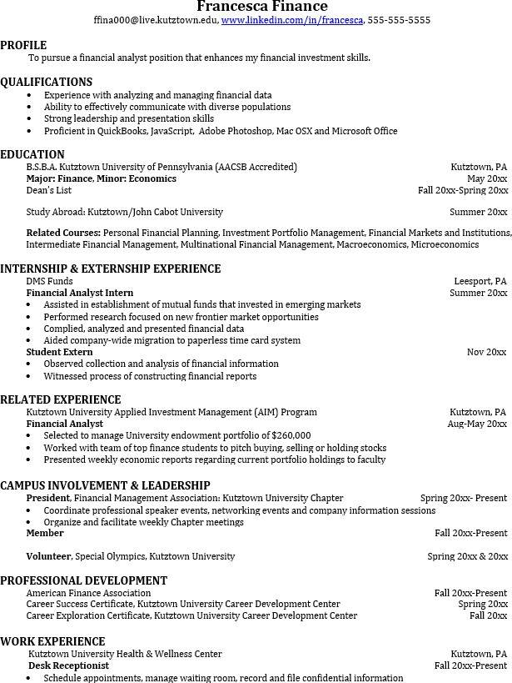
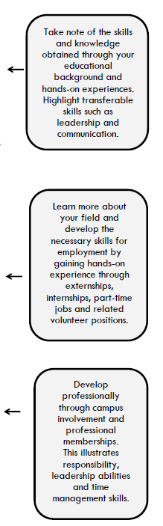
graduates who not only have the necessary educational background but also have experience applying that knowledge to real life situations.

